

Information Architecture, Wireframe and Story Board

Assignment 2 Project



EduCLaaS ECSG-BDSE-FED-1222-31Jan2023

M02. FED-1222

|  |  |
| --- | --- |
| Product Name | Applied Degree in Software Engineering (BDSE) |
| Qualification Name | Applied Degree in Software Engineering |
| Product Name | Assignment 2 |
| Module Name (BDSE) | M02. FED-1222 |

| Learner Name | Assessor Name |
| --- | --- |
| I Wayan Wahyu Khrisna Nayottama | Ms. Ayesha Shariff |

|  |  |  |
| --- | --- | --- |
| Date Issued | Completion Date | Submitted On |
| February 3rd, 2023 | Feb 27th, 2023 | Feb 22th, 2023 |

|  |  |
| --- | --- |
| Project Title | ABC Learning Center Website |

|  |
| --- |
| Learner Declaration |
| I certify that the work submitted for this assignment is my own and research sources are fully acknowledged.    Student Signature Date: Feb 22th, 2023 |

Table of Contents

Scenario and Purpose 6

Developed Branding 7

Website Purpose and Target Audience 7

Branding Personality 7

Logo and Color Scheme 7

Typography 7

Style Guide 8

Chapter 1 9

Information Architecture 9

Definition 9

Characteristic of IA 9

Advantage of IA 10

IA of The Given Scenario 11

ABC Learning Center 11

Common Content (For All Page) 11

Header from Common Content 11

Logo (For All Page) 11

Navigation (For All Page) 12

Search Bar from Header 12

Navigation (For All Page) 12

Home Page from Navigation 12

Welcome Message from Home Page 12

Brief Overview from Home Page 12

Start Button from Home Page 12

About Us Page from Navigation 13

Introduction from About Us 13

History 13

Action Button from About Us 13

Contact Us from Navigation 13

Map Location from Contact Us 13

Contact Information from Contact Us 13

FAQs from Contact Us 13

Contact Form from Contact Us 14

Action Button from Contact Us 14

Course Details from Navigation 14

Course Overview from Course Details 14

Course Images from Course Details 14

Course Details from Course Details 14

All of Each Course Pages from Course Details 14

Java, .Net, Microsoft Office, HTML Course from Course Details 14

Enrollment Information from Course Details 15

Action Button from Enrollment Information 15

Course Schedule from Navigation 15

Java, .Net, Microsoft Office, HTML Course from Course Schedule 15

Start and End Dates for Each Course from Course Schedule 15

Availability Status from Course Schedule 15

Sitemap View from Navigation 15

Action Button from Sitemap View 16

Privacy Policy from Navigation 16

Privacy Policy Content from Privacy Policy 16

Action Button from Privacy Policy Content 16

Chapter 2 17

Wireframe 17

Definition 17

Characteristic of Wireframe 17

Advantage of Wireframe 17

Wireframe of All Pages 18

Home Page 18

About Us Page 20

Contact Us Page 21

Course Details Page 22

Course Details Page Java 23

Course Details Page .Net 25

Course Detail Page Microsoft Office 26

Course Detail Page HTML 28

Course Details Page Enrollment Information 30

Course Schedule Page 31

Course Schedule Page Java, .Net, Microsoft Office, HTML 32

Sitemap Page 34

Privacy Policy Page 35

Chapter 3 36

Storyboarding 36

Definition 36

Characteristics of Storyboarding: 36

Advantages of Storyboarding: 36

Storyboard 37

Explaining The Mapping Between The Storyboard 38

Home Page next to About Us Page 38

About Us Page next to Contact Us Page 38

Contact Us Page back to About Us Page 38

Contact Us Page next to Course Details Page 38

Course Details Page back to Contact Us Page 38

Course Details Page next to Enrollment Information 39

Course Details Page learn more to All Each Course Page 39

All Each Course next to Enrollment Information 39

Enrollment Information Page back to Course Details Page 39

Enrollment Information Page next to Course Schedule Page 40

Course Schedule Page back to Enrollment Information 40

Course Schedule Page learn more to All Each Course Schedule 40

Course Schedule Page next to Sitemap Page 40

Sitemap Page back to Course Schedule Page 40

Sitemap Page next to Privacy Policy Page 40

Privacy Policy Page back to Sitemap Page 40

Chapter 4 41

Implementation 41

How Do I Implement it 41

Software and Languages Used 41

The reason for using these languages and software are as follows: 41

Hardware and Software Requirements 42

The reason for each of these requirements is as follows: 42

Common Content 44

Header 44

HTML: 44

CSS: 45

JS: 45

Footer 45

HTML: 46

CSS: 46

Home Page 47

About Us Page 47

Contact Us Page 48

Course Details Page 48

Course Details Course’s (Templated): Java, .Net, Microsoft Office, HTML 49

Enrollment Information Page 50

Course Schedule Page 50

Course Schedule Course’s (Templated): Java, .Net, Microsoft Office, HTML 51

Sitemap Page 52

Privacy Policy Page 53

Chapter 5 54

Testing and Validation 54

Why It Is Needed to Testing and Validating 54

Types Of Testing and Validation Techniques Used 54

Usability Testing 54

Functional Testing 56

Compability Testing 58

Performance Testing 60

Responsive Testing 63

Software Specify 65

Citation 65

# Scenario and Purpose

|  |
| --- |
| **Purpose of this project** |
| **Purpose of this project**  To demonstrate your capabilities in the following areas:   * Plan a Website & Develop branding, wireframes, information architecture & storyboard. |
| **Submission Format** |
| In one document, submit the following:   1. Information Architecture, 2. Wireframe, and 3. Storyboard |
| **Project Brief & Guidance** |
| **Scenario:**  You have been approached by ‘ABC Learning Center’ as a website developer to develop a company portfolio website for their institute. ‘ABC Learning Center’ is an IT Training institute that conducts courses like ‘Programming in Java’, ‘Programming in .Net’, ‘Microsoft Office’, ‘HTML’ etc. They want to design a website which can be used for providing information about their courses to students.  You will be required to design and develop this website using HTML, JavaScript, and CSS. For Assignment 1, you will be required to design following pages for the website –   1. Common Content    1. Header    2. Footer    3. Navigation 2. Home Page 3. About Us Page / Profile Page 4. Contact Us Page (Develop 1 Html page) 5. Course Details Page (Develop 2 pages, 1 for each course) 6. Course Schedule Page (Develop 2 pages, 1 for each course) 7. Sitemap Page (Develop 1 HTML page) 8. Privacy Policy Page (Develop 1 HTML page) |

# Developed Branding

### Website Purpose and Target Audience

* The purpose of the website is to provide information about the courses offered by 'ABC Learning Center' to prospective students. It serves as a portfolio website for the institute, showcasing their IT training courses such as 'Programming in Java', 'Programming in .Net', 'Microsoft Office', 'HTML' and other related information such as course duration, fees, and schedules. The website aims to attract potential students and provide them with relevant information to help them make informed decisions about enrolling in courses offered by 'ABC Learning Center.'

### Branding Personality

* Tone: The tone of the website could be informative and professional, as it is an educational institute.
* Voice: The voice of the website could be authoritative and knowledgeable, demonstrating the institute's expertise in the field of IT training.
* Style: The style of the website could be clean, modern, and easy to navigate, reflecting the institute's commitment to providing quality education and a positive user experience.

### Logo and Color Scheme

* The graduation cap and laptop logo represent a modern education method, which aligns well with the purpose of ABC Learning Center.
* The black and silver color scheme exudes a professional and sophisticated look, which enhances the credibility of the institute. The black color conveys elegance, power, and authority, while the silver color represents innovation, modernity, and technological advancement. The combination of these colors is visually appealing and creates a sense of balance and harmony.

### Typography

* The typography for ABC Learning Center would consist of Gill Sans and Roboto fonts. Gill Sans is a sans-serif font that has a modern, sleek look, while Roboto is also a sans-serif font but has a more rounded and friendly appearance. The combination of the two fonts can create a clean, professional, and easy-to-read look for the website.
* The chosen color scheme is black and silver. Black is a bold and powerful color that is often associated with sophistication, elegance, and professionalism. Silver is a metallic color that is often associated with modernity, innovation, and high-tech. The combination of black and silver can create a sleek and professional look for the website, while also conveying a sense of modernity and innovation.

### Style Guide

* Logo: The logo should feature a graduation cap and laptop with the text "ABC Learning Center" in Gill Sans and Roboto fonts. The logo should always appear in black and silver color scheme.
* Color Scheme: The color scheme for the website should consist of black and silver colors. Black should be used as the primary color for text and backgrounds, while silver should be used for accents and highlights.
* Typography: The website should use Gill Sans and Roboto fonts for headings and body text. Gill Sans can be used for headings and important information, while Roboto can be used for body text and other secondary information.
* Visual Elements: The website can also use images of students, classrooms, and computers to create a modern and professional look. These images should also complement the black and silver color scheme. Additionally, the website should use consistent layout and design elements, such as buttons, icons, and backgrounds to maintain a cohesive look and feel.

By outlining these branding elements in a style guide, ABC Learning Center can ensure consistency across their website and create a strong brand identity that resonates with the target audience.

# Chapter 1

## Information Architecture

### Definition

Information architecture (IA) refers to the process of organizing, structuring, and labeling digital content and information to improve findability, usability, and accessibility for users. It involves creating a clear and efficient structure for digital content, including website content, information systems, and databases, and then labeling that content in a way that makes sense to users. The goal of IA is to design a digital environment that is easy for users to navigate, understand, and use.

IA involves a thorough analysis of the information that is to be included in a digital environment, including the types of content and the target audience. It also involves defining the relationships between information and the ways in which it should be grouped and organized. IA practitioners must consider the goals of the user, the context in which they will use the information, and the type of information they are looking for.

Once the information has been analyzed and organized, IA practitioners use labeling, indexing, and other navigation strategies to make it easy for users to find the information they need. IA practitioners may also create site maps, wireframes, and prototypes to visualize the organization and structure of the information and to test its usability.

In summary, information architecture is an essential component of the design and development of digital environments. It plays a critical role in ensuring that digital content is easily discoverable, usable, and accessible to the people who need it. Effective IA can improve the overall user experience, enhance the credibility and professionalism of the digital environment, and increase the efficiency and productivity of users.

### Characteristic of IA

Information Architecture (IA) is a crucial aspect of web design that helps to structure and organize a website's content and features in an effective and user-friendly manner.

Some of the key characteristics of effective Information Architecture include:

* Hierarchical structure: A website should have a clear and well-defined hierarchy, which allows users to understand the relationships between different sections of the site and navigate the site effectively.
* User-centered design: IA should be designed with the needs and goals of the target audience in mind, taking into account their behaviors, preferences, and motivations.
* Findability: The structure of the site should be designed to allow users to quickly and easily find the information or content they are looking for. This requires careful consideration of the organization and labeling of content, as well as the use of search and navigation tools.
* Scalability: IA should be flexible and scalable to accommodate the changing needs and growth of the website over time.
* Consistency: The structure, labeling, and navigation of a website should be consistent across all pages and sections to ensure a smooth and seamless user experience.

### Advantage of IA

The advantages of having a well-designed Information Architecture include:

* Improved usability: A well-structured and organized website is easier for users to navigate, understand, and interact with, leading to a more enjoyable and productive user experience.
* Better findability: A well-designed IA makes it easier for users to find the information they are looking for, reducing frustration and improving their experience of the site.
* Increased engagement: A website that is easy to navigate and understand is more likely to engage users, keeping them on the site longer and encouraging them to explore more content and features.
* Better SEO: A well-structured and organized website is easier for search engines to crawl and index, improving the site's ranking in search results and increasing its visibility.
* Increased efficiency: By providing a clear and organized structure for the content and features of a website, IA helps to streamline the process of creating, managing, and updating the site, improving its efficiency and reducing the time and effort required to maintain it.

In conclusion, Information Architecture is a critical component of web design that has a significant impact on the user experience, findability, and success of a website. It requires careful consideration, planning, and execution to ensure that it supports the goals and objectives of the site and delivers a positive and productive experience for users.

### IA of The Given Scenario

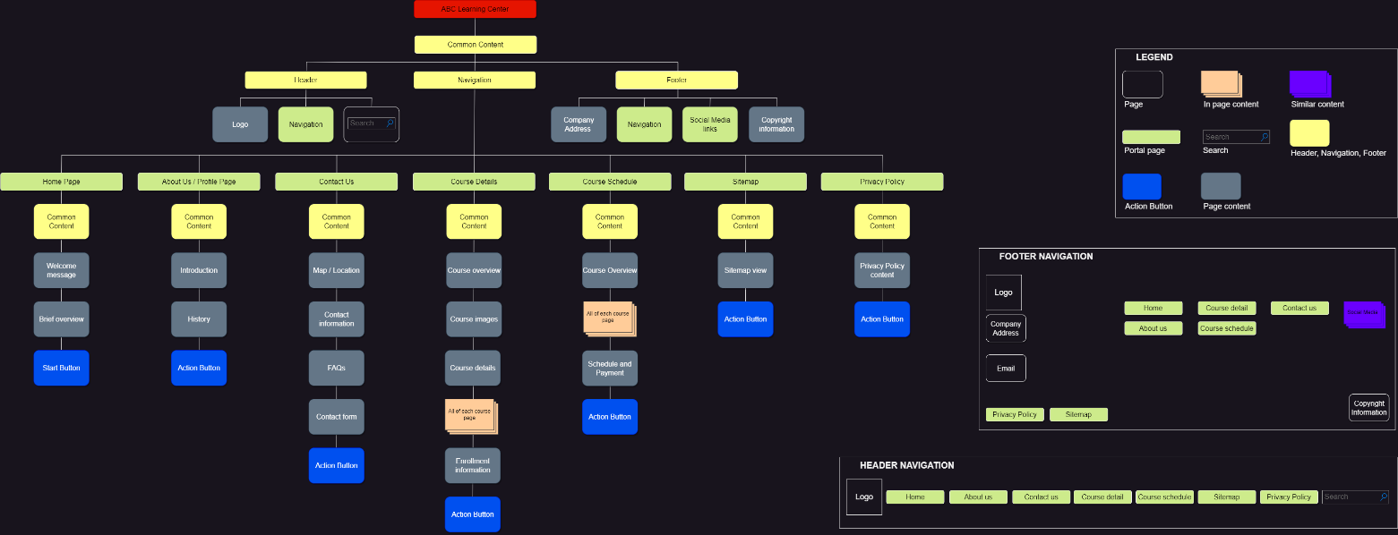

### ABC Learning Center

ABC Learning Center block in Information Architecture (IA) refers to the way the information about the institute is organized, structured, and interrelated within its website. It includes the design and layout of the website, the way information is categorized and labeled, and how users can access and navigate the information. The goal of IA is to make the website easy to use and understand for the users, in this case, the students seeking information about the courses offered by ABC Learning Center.

### Common Content (For All Page)

Common content refers to elements, navigation, and footer of a website that are consistent across all pages. It includes items such as logos, main navigation links, contact information, and other items that are fundamental to the website's structure and help users navigate the site. These elements are important in information architecture because they provide a consistent user experience and help users understand the overall structure and organization of the website.

### Header from Common Content

In Information Architecture (IA), the header block is typically the top portion of a website and contains elements such as the company logo, main navigation, and any important or high-level information, such as a call-to-action or search bar. The header provides a consistent and easily accessible area for users to access important information and navigate the website. It is designed to be the first thing a user sees when they visit a website, making it an essential part of the IA.

### Logo (For All Page)

The logo in the Information Architecture (IA) serves as the visual representation of a company or brand. It acts as an identifier for the website and helps users to quickly recognize the organization. Additionally, the logo is usually positioned in a prominent location in the header and footer, making it easily accessible from any page on the website.

### Navigation (For All Page)

The Navigation in the Information Architecture serves as a roadmap for users to access all the relevant information about the website, including Home, About us, contact us, course schedule, course details, sitemap, and privacy policy. It helps users to easily navigate and find the information they need, making their experience on the website more efficient and effective.

### Search Bar from Header

The search bar in the header block in IA serves as a tool for users to quickly search and find specific content on the website. It helps to improve the user experience by making it easier for users to find what they are looking for without having to navigate through the entire website. Additionally, it makes the website more user-friendly and efficient.

### Navigation (For All Page)

The Navigation in Common Contain block plays a key role in Information Architecture by serving as a primary means of navigation for users. It helps users quickly and easily find the information they are looking for by grouping related content into categories, and by providing clear and concise links to the different sections of a website. This improves the overall user experience and helps users find what they need with minimum effort and frustration.

### Home Page from Navigation

The Homepage in Navigation block is a crucial part of the Information Architecture (IA) as it serves as the first impression for users visiting the website of ABC Learning Center. The Homepage contains Common Content, a Welcome Message, Brief Overview, and a Start Button that provides an overview of the institute and its courses, making it easy for users to navigate and find what they are looking for. The Homepage helps set the tone and direction for the rest of the website, making it essential for creating a positive user experience.

### Welcome Message from Home Page

The Welcome Message on the Home Page in Information Architecture serves as a greeting to the website's visitors and sets the tone for the rest of their experience on the site. It provides a brief introduction to the purpose of the website and provides a starting point for visitors to explore the rest of the site's content and offerings.

### Brief Overview from Home Page

Serves as a quick reference for visitors to understand the main purpose and offerings of the institute, and to provide a general idea of what they can expect from the center. This overview is crucial in the Information Architecture as it sets the tone for the rest of the website and guides the visitor's journey.

### Start Button from Home Page

The Start button in the Home Page of the Information Architecture is an interactive element that helps users to quickly initiate a specific action or process, in this case, it likely serves as a call-to-action to start exploring the courses offered by ABC Learning Center. It is designed to be intuitive and straightforward, making it easy for users to take the first step towards finding the information they need.

### About Us Page from Navigation

The About Us page in Navigation provides a value of ABC Learning Center. It helps users understand the company and what it stands for, and provides a context for their services and offerings. The information architecture of this page helps users easily find the information they need and understand the purpose of ABC Learning Center.

### Introduction from About Us

The Introduction section in the About Us page of the Information Architecture provides a brief overview of the company, including its mission and goals. This section helps to establish the purpose and values of the organization, providing context and background information for visitors to the website.

### History

The History section in the "About Us" page of Information Architecture provides a timeline of the milestones and key events of ABC Learning Center. It helps users understand the background, growth, and evolution of the institute. This section provides a comprehensive overview of the institute's history and its journey so far.

### Action Button from About Us

The action button in the About Us page in IA serves as a link to the Contact Us page, allowing users to easily reach out and connect with ABC Learning Center. It provides a convenient way for users to access important information and get in touch with the institute.

### Contact Us from Navigation

The Contact Us section in the Navigation of the Information Architecture provides a centralized location for users to access information about the physical location of the workplace and contact information for ABC Learning Center. It also includes frequently asked questions (FAQs) and a contact form for users to easily connect with the institute. This section is designed to make it easy for users to find the information they need to contact ABC Learning Center.

### Map Location from Contact Us

The Map Location Workspace in the Contact Us section of the website provides the physical location of the ABC Learning Center to the users, so that they can easily find and reach the company. This helps users to have a better understanding of the institute's location and accessibility.

### Contact Information from Contact Us

The contact information in Contact Us provides users with the necessary details such as the address, phone number, and email address of ABC Learning Center to reach out to them with inquiries or questions. This helps users to easily get in touch with the institute and access the information they need.

### FAQs from Contact Us

The FAQs (Frequently Asked Questions) information in Contact Us section provides answers to commonly asked questions about the services and products offered by ABC Learning Center. This helps users to quickly find information about the institute and reduces the need for them to contact the institute directly.

### Contact Form from Contact Us

The Contact Form in the Contact Us page allows users to provide their personal information, such as name and level, and choose the courses they are interested in. This information is used to help us understand the needs and preferences of the users, which in turn helps us provide a better experience and support for them.

### Action Button from Contact Us

The Action Buttons in the Contact Us page allows users to navigate between pages by providing a back button to return to the About Us page, or a next button to proceed to the Course Details page. This provides a convenient way for users to move between relevant pages within the website.

### Course Details from Navigation

The Course Details section in the Navigation block of IA provides information about various courses offered by the organization. It includes a general overview of the courses, images of the courses, detailed information about each course, enrollment information, and a button to take further actions like enrolling in a course.

### Course Overview from Course Details

The "Course Overview" in Navigation is a section in the information architecture (IA) that provides a summary or overview of all the courses offered. This section is designed to give a high-level understanding of the courses and their contents.

### Course Images from Course Details

The Course Images in the Course Details section provide visual representations of the course offerings, allowing users to have a better understanding of the subject matter and structure of the courses. They can help users to make informed decisions about which courses to enroll in.

### Course Details from Course Details

The Course Details section in the Course Details provides information about the specific courses being offered, such as the course name, description, goal, outline and other relevant details about the course content and objectives. This information helps the user understand what the course covers and if it aligns with their educational goals.

### All of Each Course Pages from Course Details

The All of each course pages in Course Details provides detailed information about specific courses such as Java, .Net, Microsoft Office, and HTML. It allows the user to learn more about the course content, objectives, and other important information related to each individual course.

### Java, .Net, Microsoft Office, HTML Course from Course Details

The Java, .Net, Microsoft Office, HTML Course pages in the Course details section provide detailed information about specific courses offered by ABC Learning Center. The information of all four pages has the same template ideas, its includes a short overview, more detailed description, course objectives, and course goals to help the user understand the content and outcomes of each course.

### Enrollment Information from Course Details

Enrollment Information in Course Details is a set of instructions and information on how to enroll in a course offered by ABC Learning Center. It includes steps to select a course, review details, check eligibility, fill out the enrollment form, and receive a confirmation email. The information also includes a way to reach out to the team if there are any questions or concerns.

### Action Button from Enrollment Information

The action buttons in the Enrollment Information section allow users to navigate between pages. The back button takes the user back to the Course Details page, while the next button takes the user to the Course Schedule page. These buttons make it easy for the user to move between different sections of the website and find the information they need.

### Course Schedule from Navigation

The Course Schedule page in Navigation provides information about the start and end dates for each course, the availability of each course, and information about the trainer who will be teaching the course. It also has action buttons that allow users to navigate to other pages on the website.

### Java, .Net, Microsoft Office, HTML Course from Course Schedule

There is detailed information about each course offered, including the start and end times, price, availability, and hours per day. This information is provided to help students plan and manage their schedules, and to ensure that they can enroll in courses that fit their needs and availability. By including this information in the course schedule, the information architecture of the website helps users easily find and access the information they need to make informed decisions about which courses to take.

### Start and End Dates for Each Course from Course Schedule

The start and end dates for each course in Course Schedule displays the dates when the class begins and ends, including the day, month, and year. This information helps users know when the course will be offered and how long it will last.

### Availability Status from Course Schedule

The availability status in Course Schedule shows if the course is open for enrollment or if it has reached its maximum capacity. This information helps the user to determine if they can enroll in the course or if they need to look for alternative options.

### Sitemap View from Navigation

The Sitemap View in Navigation is a graphical representation of the structure and organization of the website. It provides an overview of all the pages, sections and categories on the website, making it easier for users to navigate and find the information they need. The Sitemap helps users understand the layout and content of the website and how everything is related.

### Action Button from Sitemap View

The action buttons in the Sitemap section of the navigation allow users to either go back to the Trainer Information page or move to the Privacy Policy page. The buttons allow for navigation and movement between different sections of the website.

### Privacy Policy from Navigation

The Privacy Policy page in Navigation provides information on how ABC Learning Center collects, uses, and protects personal information of its users. It outlines the types of information that is collected, the purposes for which it is used, and the measures taken to secure the information.

### Privacy Policy Content from Privacy Policy

The Privacy Policy in Navigation is a statement that explains how the website collects and uses personal information from its users. It also outlines measures taken to protect the information and explains the circumstances under which information may be shared with outside parties. The policy can be changed at any time and by using the website, users agree to its terms.

### Action Button from Privacy Policy Content

The back button in the privacy policy content allows the user to return to the sitemap page, providing navigation options and allowing the user to easily access other parts of the website.

# Chapter 2

## Wireframe

### Definition

A wireframe is a visual representation of a website or application's user interface that is used to plan and design its layout, functionality, and content structure. It is a low-fidelity representation of the user interface that is created using simple shapes and lines, and typically does not include color, images, or typography. Wireframes are essential in the design process as they allow designers and stakeholders to plan and test the user experience before creating a more detailed, high-fidelity prototype.

### Characteristic of Wireframe

* Simple: Wireframes are simple, low-fidelity visual representations of the user interface design. They are free from visual details, graphics, and colors.
* Focus on functionality: Wireframes emphasize functionality over aesthetics, focusing on the layout, structure, and navigation of the interface.
* Easily modifiable: Wireframes are easy to modify and iterate as the design process evolves.
* Cost-effective: Wireframes are a cost-effective solution compared to other design methods because they do not require a significant amount of time or resources to create.
* Communicative: Wireframes serve as a visual tool for communicating design concepts, ideas, and feedback between stakeholders, developers, and designers.

### Advantage of Wireframe

* Early visualization: Wireframes provide an early visualization of the user interface, allowing stakeholders to see and evaluate the design before it is fully developed.
* Better understanding of design: Wireframes help stakeholders understand the design concepts and layout of the interface, allowing them to provide feedback and make changes before the development process begins.
* Improved collaboration: Wireframes facilitate collaboration between designers, developers, and stakeholders, improving the overall design process and ensuring that everyone is on the same page.
* Streamlined design process: Wireframes help streamline the design process by breaking it down into smaller, manageable stages, making it easier to manage and iterate the design.
* Efficient problem-solving: Wireframes provide a visual representation of the user interface, making it easier solve design problems before they occur.

### Wireframe of All Pages

### Home Page

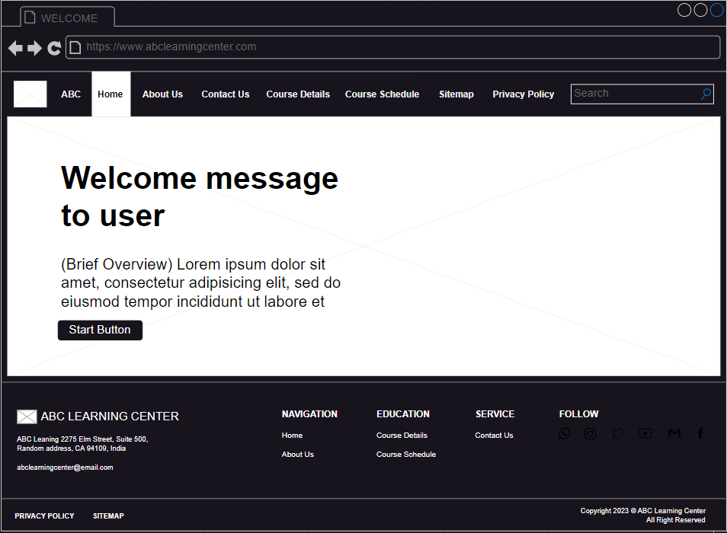

* Common content (ALL PAGES CONTAINED WITH THESE): This includes a header, navigation, and footer, which will be present on all pages of the website to provide consistency and ease of navigation.
* Header: The header features the logo of the company and a horizontally aligned navigation menu that includes options such as Home, About Us, Contact Us, Course Details, Course Schedule, Sitemap, Privacy Policy, and a search bar. The navigation menu buttons and search bar are clickable and allow users to easily navigate the website. By clicking on a navigation button, users can be directed to the page of their choice. The search bar allows users to search for specific content within the same page as the search bar. This common layout provides consistency and ease of navigation for users.
* Navigation: The navigation menu is a list of links located in the header or footer of the website. The links in the navigation menu allow the user to quickly access different sections of the website. The navigation menu in the ABC Learning Center website includes links to the Home, About Us, Contact Us, Course Details, Course Schedule, Sitemap, and Privacy Policy pages. By clicking on any of these links, the user will be taken to the corresponding page, allowing for ease of navigation and a seamless user experience
* Footer: The footer of the ABC Learning Center website includes the company logo, company address, and company email. There is also a navigation menu with links to various pages on the site, including Home, About Us, Contact Us, Course Details, Course Schedule, Sitemap, and Privacy Policy. The footer also features links to all of the company's social media accounts, as well as a copyright notice. The footer provides easy access to important information about the company and its offerings, and users can click on the company email link or any of the navigation menu links to be taken to the relevant page. Additionally, users can click on the links to the company's social media accounts to follow and interact with the company on those platforms.
* Welcome message: The Welcome message is a friendly greeting that welcomes users to the website and sets the tone for their experience.
* Brief overview of courses: This section provides a short view of the ABC Learning Center. It gives the users a quick idea of what to expect and what user can learn.
* Start button: The Start button takes the users to the About Us page, where they can learn more about the learning center.

### About Us Page

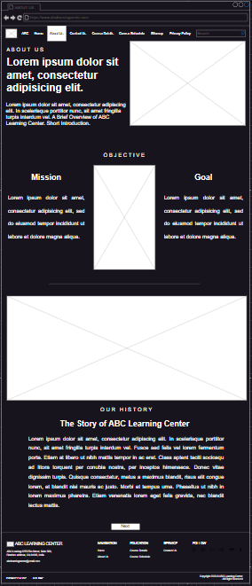

* Brief Overview: A concise summary of what ABC Learning Center is and what it offers.
* History: The origin and evolution of ABC Learning Center.
* Mission and Goal: The purpose and objectives of ABC Learning Center, including what need to aim and to achieve also how we plan to do it.
* Next Button: A button that allows users to navigate to the Contact Us page.

### Contact Us Page

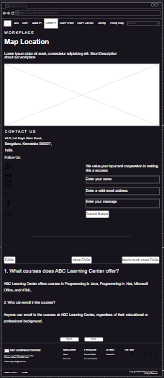

* Map Location: A picture of ABC Learning Center workplace and its description is displayed, allowing users to have a visual idea of the physical location of the center.
* Contact Forms: Users can use the contact form to input their name, email address, and message, and submit it to the center using the submit button.
* Company Address: The address of ABC Learning Center and its phone number are displayed, along with links to various social media platforms like WhatsApp, Instagram, Facebook, Gmail, Twitter, and YouTube.
* FAQs: A list of frequently asked questions and their answers are provided to help users get the information they need. Already made in Tabs Layout as required by the assignment.
* Action Button: There are two action buttons available:
* Back button that takes users back to the About Us page.
* Next button that takes them to the Course Details page.

### Course Details Page

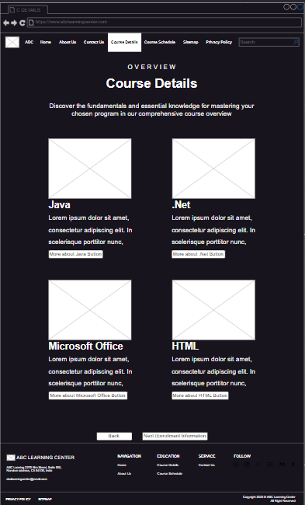

* Sample Images: This includes header images for each course to give an idea of what each course looks like.
* Course Brief: A short description of each course is provided to give users an overview of what each course entails.
* Action Buttons: The page includes several action buttons including:
* Link to each course that provides a direct link to each course allowing users to quickly access the course they're interested in.
* Back Button that allows users to go back to the Contact Us page.
* Next Button that takes users to the Enrollment Information page.

### Course Details Page Java

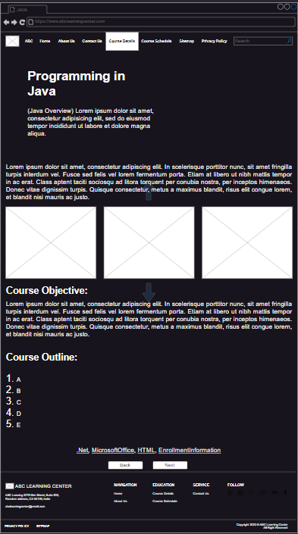

* Short Brief of Java Overview: A brief introduction to what Java is.
* Long Brief of Java Overview: A comprehensive overview of Java.
* Java Sample images: A visual representation of Java projects and applications.
* Course Objectives: A list of specific goals and outcomes that students can expect to achieve after completing the Java course.
* Course Outline: A numbered list of topics and subtopics that will be covered in the Java course, organized in a logical and sequential manner.
* Action Button: A collection of buttons that provide navigation options for users, including links to other courses, enrollment information, and the ability to go back or move forward to different pages.
* .Net Course Link: A button that allows users to navigate to the .Net course page.
* Microsoft Office Course Link: A button that allows users to navigate to the Microsoft Office course page.
* HTML Course Link: A button that allows users to navigate to the HTML course page.
* Enrollment Information Link: A button that allows users to access the enrollment information page.
* Back Button: A button that allows users to return to the previous page.
* Next Button: A button that allows users to move forward to the next page.

### Course Details Page .Net

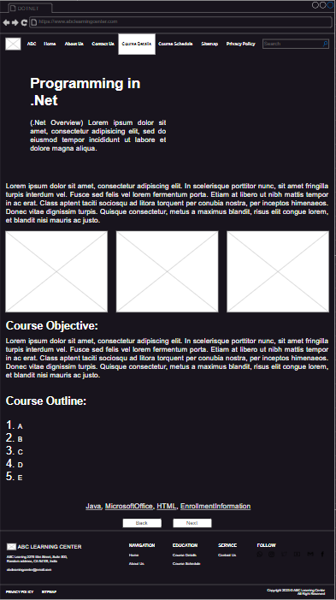

* Short Brief Overview: A brief summary of what the .Net course is all about.
* Long Brief Overview: An in-depth explanation of the .Net course.
* Sample Images: Visual aids to help users better understand the course.
* Course Objectives: A list of the goals and objectives of the .Net course.
* Course Outline: A numbered list of the topics covered in the .Net course.
* Action Buttons:
* Java Course Link: A button that takes users to the Course Details Page for Java.
* Microsoft Office Course Link: A button that takes users to the Course Details Page for Microsoft Office.
* HTML Course Link: A button that allows users to navigate to the HTML course page.
* Enrollment Information Link: A button that takes users to the Enrollment Information page.
* Back Button: A button that takes users back to the previous page.
* Next Button: A button that takes users to the next page.

### Course Detail Page Microsoft Office

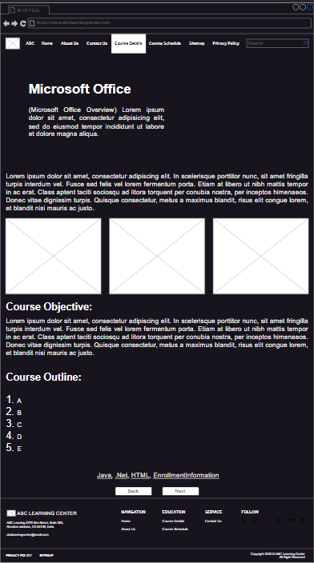

* Short Brief of Overview provides a brief overview of what Microsoft Office is and what it entails.
* Long Brief of Overview provides a more in-depth explanation of what Microsoft Office is, what it can do, and what benefits it offers.
* Sample images displays sample images of Microsoft Office, giving users a visual representation of what they can expect to learn in the course.
* Course Objectives lists out the key objectives that users can expect to achieve by taking the Microsoft Office course.
* Course Outline presents the course content in a structured and organized manner, making it easy for users to follow along and understand what they will be learning.
* Action Buttons:
* Java Course Link: A button that takes users to the Course Details Page for Java.
* .Net Course Link: A button that takes users to the Course Details Page for .Net.
* HTML Course Link: A button that allows users to navigate to the HTML course page.
* Enrollment Information Link: A button that takes users to the Enrollment Information page.
* Back Button: A button that takes users back to the previous page.
* Next Button: A button that takes users to the next page.

### Course Detail Page HTML

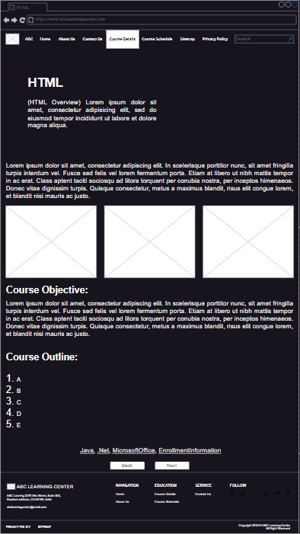

* Short Brief of Overview provides a brief overview of what HTML is and what it entails.
* Long Brief of Overview provides a more in-depth explanation of what HTML is, what it can do, and what benefits it offers.
* Sample images displays sample images of HTML, giving users a visual representation of what they can expect to learn in the course.
* Course Objectives lists out the key objectives that users can expect to achieve by taking the HTML course.
* Course Outline presents the course content in a structured and organized manner, making it easy for users to follow along and understand what they will be learning.
* Action Buttons:
  + Java Course Link: A button that takes users to the Course Details Page for Java.
  + .Net Course Link: A button that takes users to the Course Details Page for .Net.
  + Microsoft Office Course Link: A button that allows users to navigate to the HTML course page.
  + Enrollment Information Link: A button that takes users to the Enrollment Information page.
  + Back Button: A button that takes users back to the previous page.
  + Next Button: A button that takes users to the next page.

### Course Details Page Enrollment Information

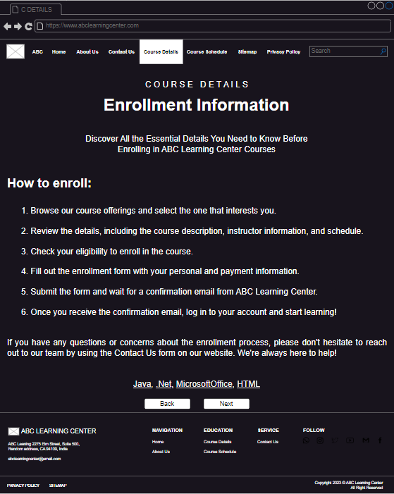

How to Enroll: A section that provides information about the steps to enroll in a course at ABC Learning Center.

Action Buttons:

* + Java Course Link: A button that takes users to the Course Details Page for Java.
  + .Net Course Link: A button that takes users to the Course Details Page for .Net.
  + Microsoft Office Course Link: A button that allows users to navigate to the HTML course page.
  + HTML Course Link: A button that allows users to navigate to the HTML course page.
  + Back Button: A button that returns users to the Course Details page.
  + Next Button: A button that takes users to the Course Schedule page.

### Course Schedule Page

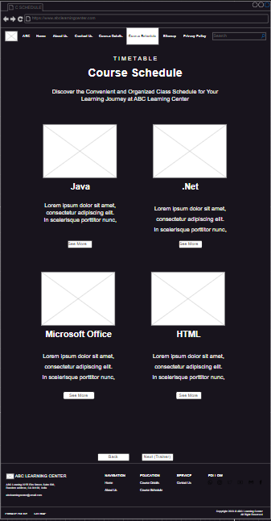

* Course Images: The user is able to view images related to the course, providing them with a visual representation of what the course is about.
* Action Button:
* Course See More Links: The user is able to access links to sign up page.
* Back Button: The user is able to return to the previous page, the Course Details page, by clicking on the back button.
* Next Button: The user is able to proceed to the next page, the Sitemap page, by clicking on the next button.

### Course Schedule Page Java, .Net, Microsoft Office, HTML

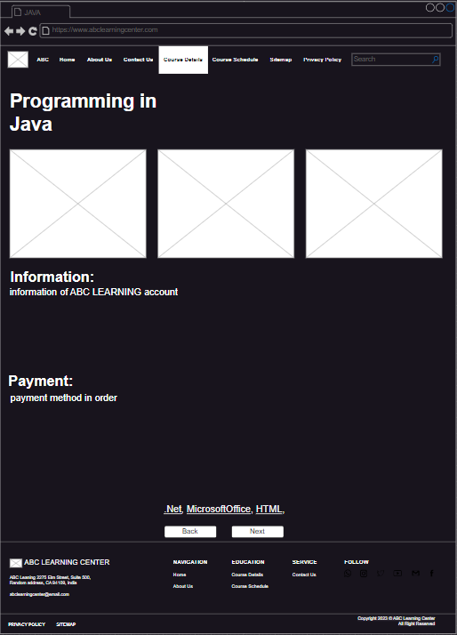

* Sample images displays sample images of HTML, giving users a visual representation of what they can expect to learn in the course.
* Information of ABC Learning Center Account so that the user can complete the payment as the procedure given below
* Payment of how to exactly pay and receive some information regarding all the payment of ABC Learning Center
* Action Buttons:
  + Java Course Link: A button that takes users to the Course Schedule Page for Java.
  + .Net Course Link: A button that takes users to the Course Schedule Page for .Net.
  + Microsoft Office Course : A button that takes users to the Course Schedule Page for Microsoft Office.
  + HTML Link: Link: A button that allows users to navigate to the HTML course schedule page.
  + Enrollment Information Link: A button that takes users to the Enrollment Information page.
  + Back Button: A button that takes users back to the Course Schedule home page.
  + Next Button: A button that takes users to the Sitemap page.

### Sitemap Page

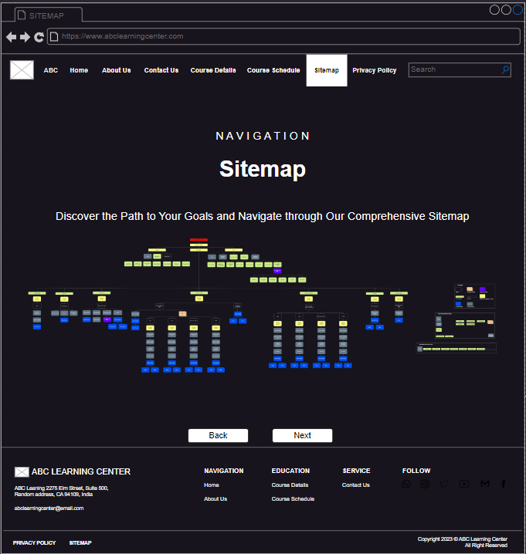

* Sitemap: The sitemap displays a comprehensive map of the ABC Learning Center website. The map includes all the content, links, and components of the website, making it easy for the user to navigate and understand the structure of the site. The giant sitemap provides a clear overview of the website and helps the user to quickly locate the information they are looking for.
* Action Button:
* Back Button: This button allows the user to return to the Course Schedule page.
* Next Button: This button takes the user to the Sitemap page.

### Privacy Policy Page

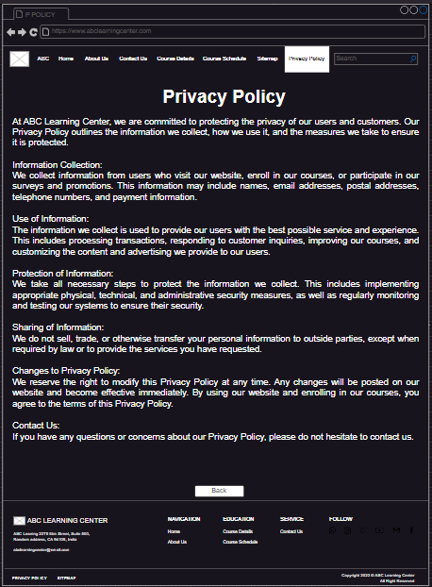

* Privacy Policy: In the Privacy Policy Page, the user is presented with the Privacy Policy content which outlines the policies and procedures regarding the protection and use of personal information collected by ABC Learning Center.
* Back Button: When clicked, takes the user back to the Sitemap page. This allows the user to easily navigate back to the previous page if needed.

# Chapter 3

## Storyboarding

### Definition

storyboarding refers to the process of creating a visual representation of the user experience and user journey. It is a method used to plan and organize the content, layout, and functionality of a website or application. The purpose of storyboarding in ABC Learning Center is to provide a clear and comprehensive understanding of how the user will navigate through the site and interact with its various components. This process allows the design team to identify potential issues and make necessary changes before development begins, ensuring a seamless and user-friendly experience for users.

### Characteristics of Storyboarding:

* Visual representation of a project
* Depiction of a project's flow and structure
* Breakdown of a project into smaller and manageable components
* Use of sketches, illustrations, or images to show the flow of the project
* A sequential representation of the different steps involved in a project

### Advantages of Storyboarding:

* Improved communication and collaboration
* Better understanding of the project requirements
* Efficient planning and organization of resources
* Improved visualization of the end goal
* Reduced rework and mistakes
* Increased chances of project success
* Facilitation of the decision-making process
* Enhanced visualization of the story or project narrative
* Increased creativity and innovation
* Better control over the project timeline and budget.

### Storyboard

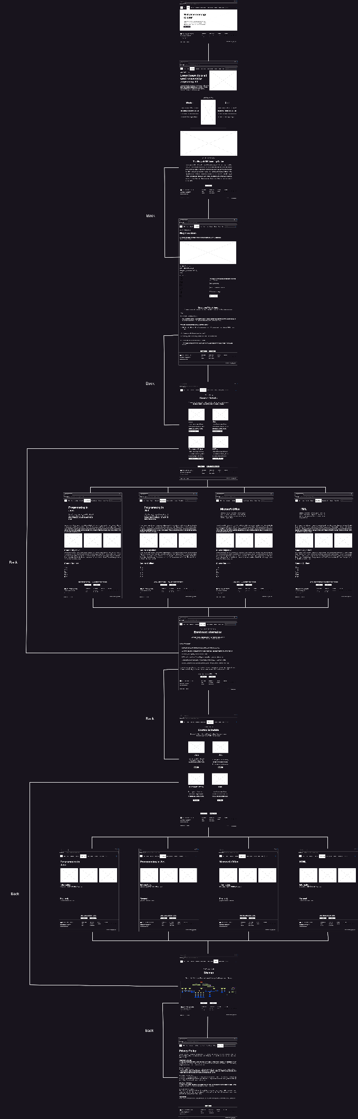

### Explaining The Mapping Between The Storyboard

### Home Page next to About Us Page

In ABC Learning Center, the mapping between the Home Page and the About Us Page is designed to provide users with a clear and intuitive navigation experience. When a user clicks on the "Start" button on the Home Page, they are taken to the About Us Page, where they can learn more about the history and mission of the ABC Learning Center. The mapping between the two pages is designed to be straightforward and user-friendly, with clear buttons and links that guide the user from one page to the next. Additionally, the About Us Page is designed to provide users with all the information they need to understand the purpose and values of the ABC Learning Center, with clear and concise language, images, and multimedia elements. By mapping the Home Page to the About Us Page, the ABC Learning Center provides users with an easy and intuitive way to learn more about the center and its mission, helping them to feel more confident and informed as they explore the rest of the site.

### About Us Page next to Contact Us Page

The mapping between the storyboard of the About Us page to the Contact Us page involves a connection between two separate pages of the ABC Learning Center's website. In the About Us page, the user is presented with information about the ABC Learning Center, its history, mission, and values. By clicking on the "Next" button, the user is then taken to the Contact Us page where they can reach out to the ABC Learning Center to ask questions, provide feedback, or request more information. The mapping between the two storyboards ensures a seamless navigation experience for the user, allowing them to easily find the information they need about the ABC Learning Center and easily reach out to the center for additional support.

### Contact Us Page back to About Us Page

The mapping between the storyboard of the Contact Us page and the About Us page can be easily understood by clicking on the back button. When the user clicks on the back button in the Contact Us page, it will direct them to the About Us page. This allows the user to easily navigate between the two pages and access the information they need. The back button serves as a navigation tool that makes it easier for the user to move between pages and find the information they are looking for.

### Contact Us Page next to Course Details Page

On the Contact Us page, there is a button labeled "Next." When the user clicks on this button, they are taken to the Course Details page. The Course Details page contains information about the courses offered at the ABC Learning Center, including a brief overview, detailed information, course objectives, a course outline, and links to related courses. The mapping between the Contact Us page and the Course Details page helps the user navigate through the ABC Learning Center website and find the information they need to make informed decisions about their education. By clicking the "Next" button on the Contact Us page, the user is able to access the Course Details page, where they can learn more about the courses offered and decide which course is right for them.

### Course Details Page back to Contact Us Page

In the storyboard of ABC Learning Center, the mapping between the Course Details page and the Contact Us page can be understood by clicking the back button. When the user is on the Course Details page and decides to return to the Contact Us page, they can click the back button. This will take them back to the Contact Us page, where they can access information about the ABC Learning Center's contact details and methods of communication. This mapping between the two pages allows for easy navigation and helps the user access the information they need quickly and efficiently.

### Course Details Page next to Enrollment Information

The Course Details Next button is the gateway to enrolling in the course of your choice. Clicking on this button will take you to the Enrollment Information page, where you can provide your personal and payment details. This page also displays the course start and end dates, hours per day, price, and availability. Please make sure to review this information before submitting your enrollment to ensure that you are enrolling in the course that meets your requirements. Once you complete the enrollment form, you will receive a confirmation email with further instructions to help you get started with your course.

### Course Details Page learn more to All Each Course Page

The Course Details for Each Course page provides a more detailed description of each course, including its objectives and outline. This information allows students to gain a deeper understanding of what they will be learning in the course, and whether it aligns with their interests and goals. By including this information, the course provider can help students make an informed decision about which course to enroll in, rather than simply relying on a course title or brief summary. This ultimately benefits both the student and the provider, as it can lead to more satisfied students and more successful courses.

### All Each Course next to Enrollment Information

When viewing the storyboard for each individual course, the user can navigate to the Enrollment Information page by clicking on the "Next" button. This button will direct the user from the current course page to the Enrollment Information page. The mapping between the two storyboard pages will follow the navigation flow established by the button, allowing for an intuitive and streamlined experience for the user. This makes it easy for the user to move from viewing course information to enrolling in the course, making the process simple and straightforward.

### Enrollment Information Page back to Course Details Page

When the user clicks the "back" button on the Enrollment Information Page, they are directed back to the previous page, which is the Course Details Page. This allows the user to review or make changes to the course they previously selected and read more information about it before enrolling. This helps ensure that the user has all the necessary information before making a decision to enroll in a course. The mapping between the Enrollment Information Page and the Course Details Page helps provide a seamless user experience and makes it easier for the user to navigate the ABC Learning Center website.

### Enrollment Information Page next to Course Schedule Page

Once the student has filled in the required information, they can click on the "Next" button to proceed to the Course Schedule Page. The Course Schedule Page provides a more detailed overview of the course, including images, duration, start and end dates, and availability status. The mapping between the two pages is a progression from the student providing their personal information to viewing the details of the course they are interested in. By clicking the "Next" button on the Enrollment Information Page, the student can see the schedule and other relevant information about the course they want to enroll in.

### Course Schedule Page back to Enrollment Information

In the storyboard of ABC Learning Center, the mapping between the Course Schedule Page and the Enrollment Information Page can be accomplished by clicking the "back" button. When the user is on the Course Schedule Page and wants to return to the Enrollment Information Page, they can simply click the "back" button. This will take them back to the Enrollment Information Page where they can make any changes to their enrollment information. This mapping is a way to navigate easily between pages within the ABC Learning Center's website.

### Course Schedule Page learn more to All Each Course Schedule

A "Learn More" button on the Course Schedule page can provide additional information about a particular course, such as ABC Learning Center Account, Payment Information, Payment Methods. This helps to ensure that students have a clear understanding of what they can expect from each course and can choose the ones that best meet their needs and interests.

### Course Schedule Page next to Sitemap Page

The "Next" button on the Course Schedule page is designed to lead users to the Sitemap page, providing an easy way to navigate through the website and explore additional resources beyond the course schedule.

### Sitemap Page back to Course Schedule Page

In the Sitemap Page of ABC Learning Center, clicking on the back button will take the user to the previous page, which is the Trainer Information Page. This allows the user to easily navigate through the different pages of the website and revisit information they may have missed or want to review.

### Sitemap Page next to Privacy Policy Page

The user is on the Sitemap Page and wants to know more about the privacy policy of ABC Learning Center. To do this, the user can click the "Next" button. By clicking the "Next" button, the user is directed to the Privacy Policy Page. On this page, the user will find the privacy policy content of ABC Learning Center.

### Privacy Policy Page back to Sitemap Page

In case the user wants to go back to the previous page, the Sitemap Page, the user can click the "Back" button. By clicking the "Back" button, the user is redirected to the Sitemap Page.

# Chapter 4

## Implementation

### How Do I Implement it

* My requirement as a website developer is to design and develop a company portfolio website for 'ABC Learning Center' using HTML, JavaScript, and CSS. The website should provide information about the courses offered by the institute, including 'Programming in Java', 'Programming in .Net', 'Microsoft Office', and 'HTML'. The website should be user-friendly, informative, and visually appealing, to attract potential students to the institute.
* Next, I created a wireframe and IA to provide a visual representation of the website. This helped me to get a better sense of the layout, user interface, and functionality of the site.
* I then began coding the website, starting with the homepage and the navigation menu, header, footer. I used HTML, CSS, and JavaScript to create the website's structure, design, and interactivity.
* After the development phase, I thoroughly tested the website to ensure that it was functioning properly, and made any necessary adjustments to improve its performance.

### Software and Languages Used

The software and languages used in developing the ABC Learning Center website include:

* HTML: This is the standard markup language used for creating web pages. It is essential for structuring the content of the website and creating the overall layout.
* CSS: This is used to style the website, creating visual appeal and ensuring that the website is user-friendly.
* JavaScript: This is used to create dynamic and interactive web pages. It enables the website to respond to user input and perform various functions, such as form validation, pop-ups, and other interactive features.

### The reason for using these languages and software are as follows:

* HTML is used as the foundation of the website since it is the standard markup language that is essential for creating web pages. It enables us to structure the content of the website and provide a framework for other technologies to interact with.
* CSS is used to create the visual elements of the website. It is essential in creating an aesthetically pleasing user interface and makes the website more user-friendly.
* JavaScript is used to create interactive elements on the website, such as form validation and other dynamic elements. It is also essential in creating responsive design, which is important in modern web development.

### Hardware and Software Requirements

|  |  |
| --- | --- |
| Category | Requirement |
| Hardware | Computer with at least 4GB of RAM  Monitor with minimum resolution of 1366x768 pixels |
| Software | Testing on various devices and screen sizes |
|  | Frameworks or libraries for responsive design such as Bootstrap or Foundation |
| Responsive Design | CSS media queries for responsive design  Testing on various devices and screen sizes  Frameworks or libraries for responsive design such as Bootstrap or Foundation |
| Libraries/Plugins | JavaScript libraries such as jQuery, React, or Vue for dynamic interactions and effects  CSS preprocessor such as Sass or LESS for more efficient CSS development  Task runners such as Grunt or Gulp for automating repetitive tasks  Image optimization software to reduce file size and improve website loading speed  Accessibility tools such as screen readers or color contrast checkers |

### The reason for each of these requirements is as follows:

* Hardware: A computer with sufficient RAM is necessary to run development tools and processes smoothly, while a monitor with a minimum resolution is needed for designing and testing the website's layout and responsiveness.
* Operating system: The choice of operating system depends on the developer's preference and familiarity, as most modern web development tools are cross-platform.
* Text editor/IDE: A text editor or IDE is used for writing code, and various options exist depending on the developer's preference.
* Web browser: A web browser is necessary to test the website's functionality and appearance.
* Version control software: Using version control software such as Git allows developers to collaborate, track changes, and revert to previous versions if necessary.
* Responsive design: Responsive design is important to ensure that the website is accessible and functional on various devices and screen sizes.
* Libraries/Plugins: Libraries and plugins can greatly simplify development and provide useful features that may not be available with raw HTML, CSS, and JavaScript.
* Image optimization software: Optimizing images can improve website performance by reducing the time it takes for pages to load.
* Accessibility tools: Accessibility is important to ensure that the website is usable by individuals with disabilities.

### Common Content

### Header

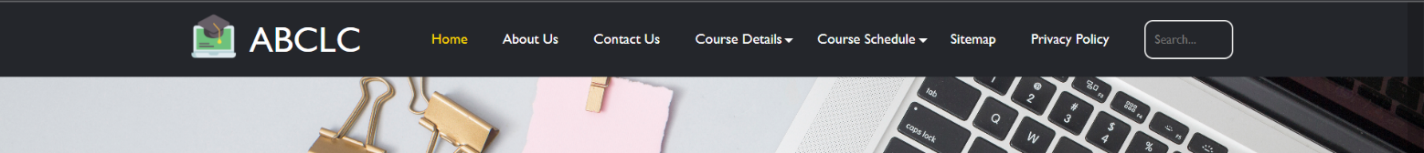

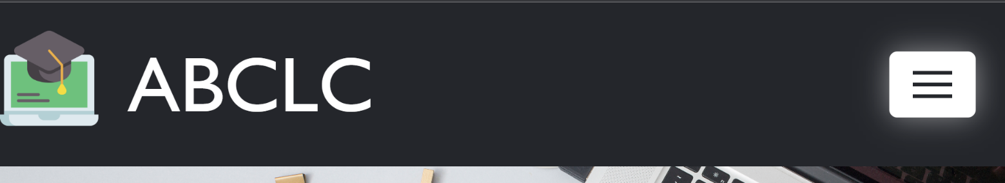

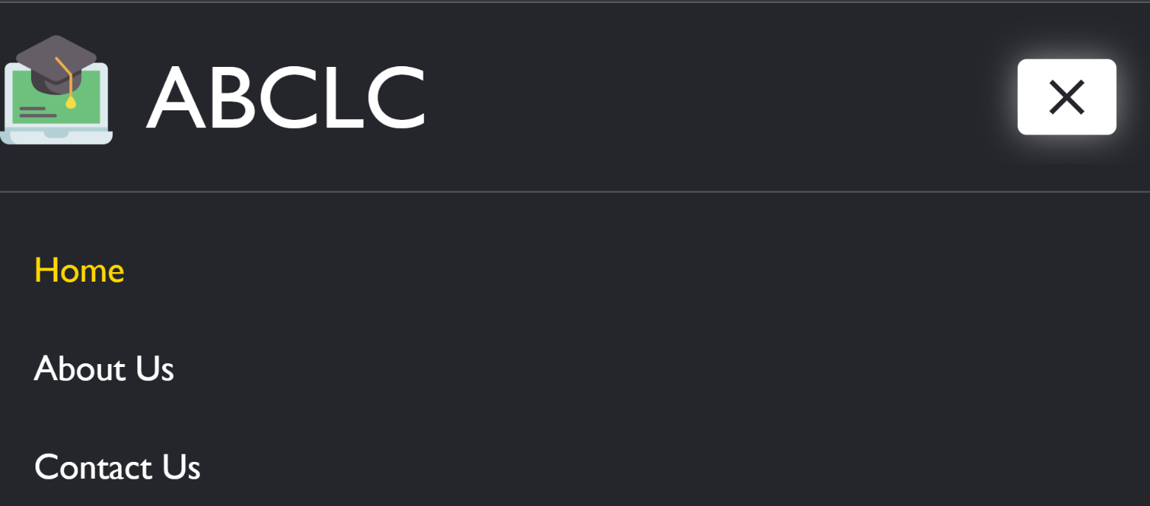

### HTML:

* The header starts with a header element containing a div element with the class container, which is used to wrap the entire header content.
* Within the container div, there is another div element with the class row which is used to align its content vertically. This row has two child div elements, the first one with the class logo contains an img element and an anchor tag with the class abclc, and the second div element contains a button element with the class nav-toggler and a nav element with a nested ul element.
* The navigation menu contains several li elements, each with an a element. The first li is set as the active link with the active class, and the next two li elements have a dropdown class that, when clicked, reveals a sub-menu containing additional links.
* Finally, the header contains a search bar, which is wrapped in a div element with the class search-bar and an input element with the type attribute set to text. The search bar also contains a div element with an id of content, which is initially empty but is used to display the search results.
* The header is followed by a script element that links to an external JavaScript file that is used to control the navigation menu.

### CSS:

* The @import rule is used to import a font family from Google Fonts.
* The main selector sets the height of the header to 80% of the viewport height and centers its content vertically and horizontally. It also sets a background image that is positioned and sized to cover the entire header.
* The homecontainer class is used to center and limit the width of the content within the header.
* The homecontent class is used to set the text alignment, maximum width, and bottom margin of the content within the header.
* The h1 and p selectors define the font family, color, and bottom margin of the heading and paragraph elements within the header.
* The homebtn class defines the styling for a call-to-action button within the header, including font family, background color, text color, padding, border radius, and hover animation.
* The @media rules define how the header should be styled at different screen sizes, with the max-width and min-width conditions and the corresponding property changes.

### JS:

* JavaScript code adds a click event listener to an HTML element with the class "nav-toggler". When the element is clicked, it triggers the function "navToggle".
* In the "navToggle" function, it toggles the class "active" on the "nav-toggler" element, which will apply the relevant CSS styles to create an animated effect.
* It also selects an HTML element with the class "nav" and toggles the class "open" on it, which will display or hide the navigation menu depending on its current state.
* Finally, it checks if the "nav" element has the "open" class, and if so, it sets the maximum height of the "nav" element to its scroll height, effectively revealing the full height of the menu. If the "nav" element does not have the "open" class, it removes the inline style that was set previously.

### Footer

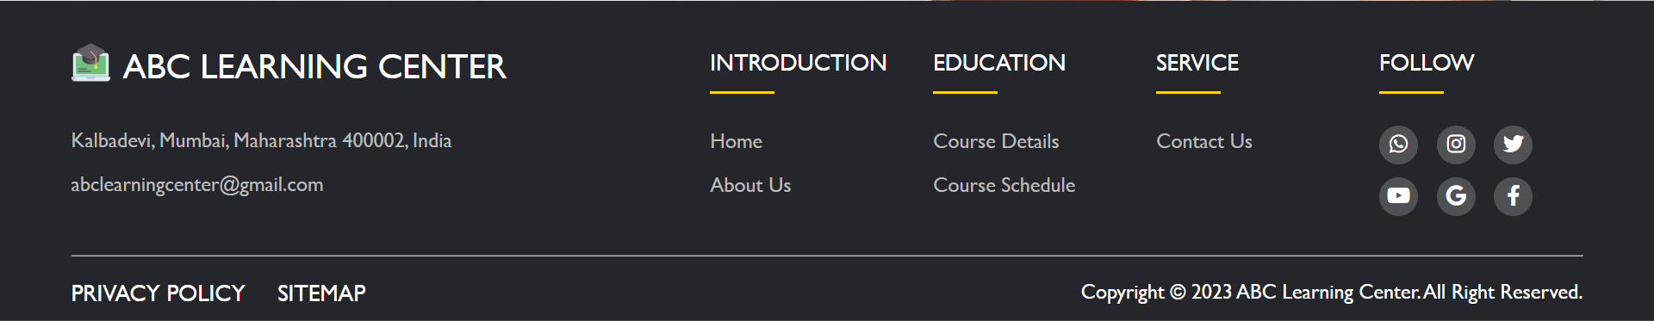

For the footer section it includes a logo, a company name, an address, an email, and links to different sections of the website such as Home, About Us, Course Details, Course Schedule, and Contact Us. It also has social media links to WhatsApp, Instagram, Twitter, YouTube, Google, and Facebook. At the bottom, it has links to Privacy Policy and Sitemap, and a copyright notice.

### HTML:

The footer element is defined with the class "footer" and contains a div element with the class "footercontainer". Within the "footercontainer" div, there is a div element with the class "footerrow" that contains the following content:

* An image with the source file "abclearningcenterlogo2.png".
* A div element with the class "footer-coll" that contains the name of the learning center ("ABC LEARNING CENTER") and two links: one for the address and another for the email address of the center.
* Four div elements with the classes "footer-col" that each contain a heading and a list of links to the different pages of the website: Home, About Us, Course Details, Course Schedule, and Contact Us.
* A div element with the class "social-links" that contains icons for different social media platforms, including WhatsApp, Instagram, Twitter, YouTube, Google, and Facebook.
* At the bottom of the footer, there is a horizontal rule element defined with the class "footerzero" and three links defined with classes "footerone", "footertwo", and "footerthree". The first two links are for the Privacy Policy and Sitemap pages of the website, respectively. The third link contains a copyright notice for the website.

### CSS:

* The first section sets some default styles for all elements inside the footer, such as setting the line-height to 1.5, setting margin and padding to 0, centering content, using box-sizing, and specifying a font-family.
* The ".footercontainer" class is used to set the maximum width of the footer and center it horizontally.
* The ".footerrow" class uses flexbox to arrange the footer content in a row and the "ul" tag is used to remove the default list-style of unordered lists.
* The ".footer" class sets the background color and adds padding to the footer.

### Home Page

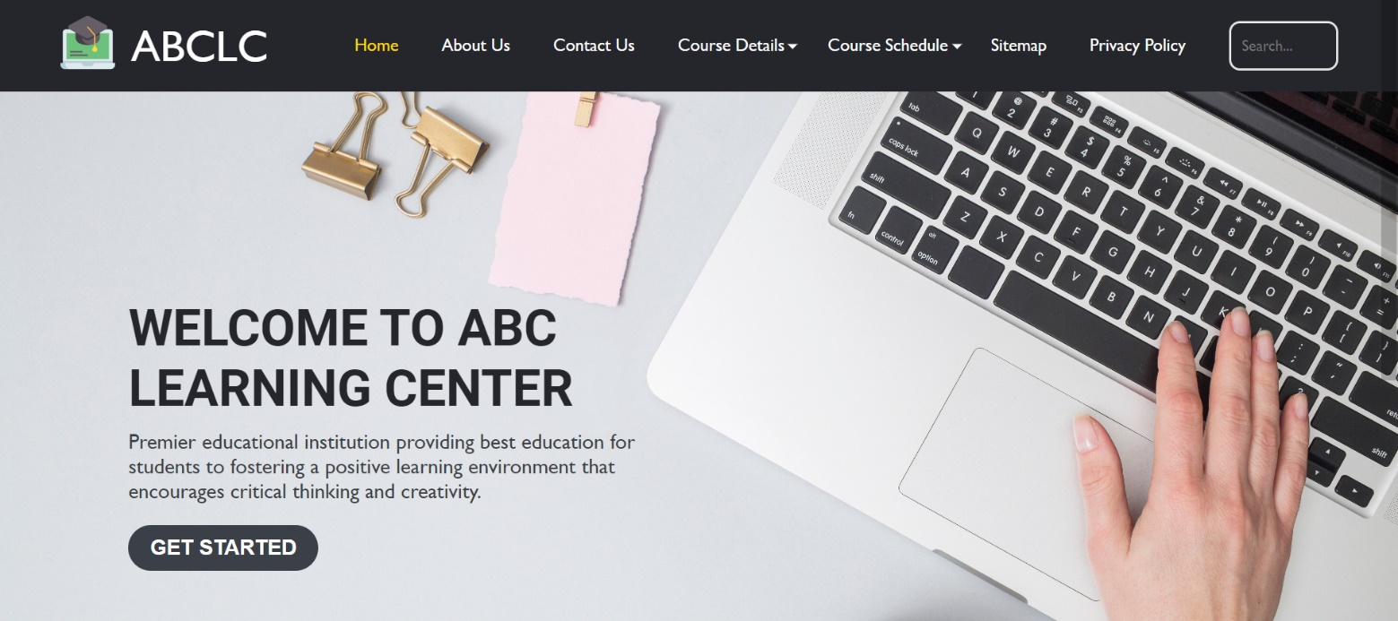

Home page includes the page header, main content, and footer. The header contains a navigation bar with links to different pages, a search bar, and a logo. The main content contains a welcome message and a button to get started into about us page. The footer includes information about the institution and links to different pages. The code also includes references to external CSS and JavaScript files for styling and functionality.

### About Us Page

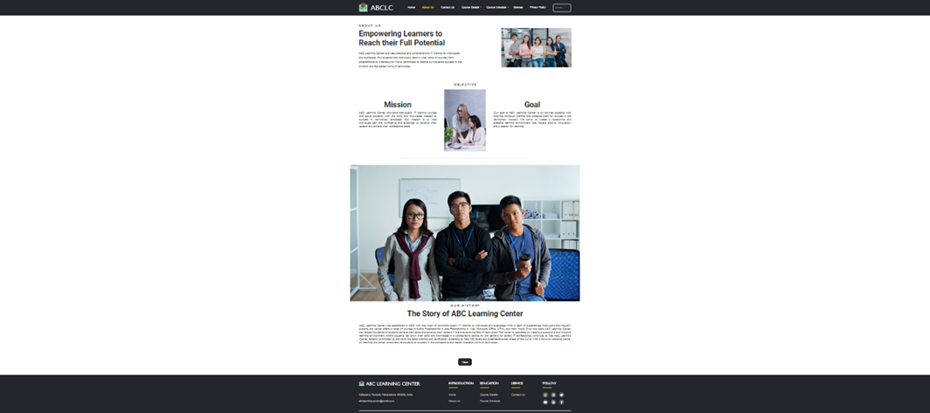

The document contains various sections including a header, main content, and footer. The main content includes sections about the center's mission and goals, as well as its history. The page also includes links to other pages on the site like the Next button that link the user to Contact Us Page, including course details, course schedules, contact information, and more. The design features a simple and professional color scheme, with images and text that convey a sense of purpose and expertise.

### Contact Us Page

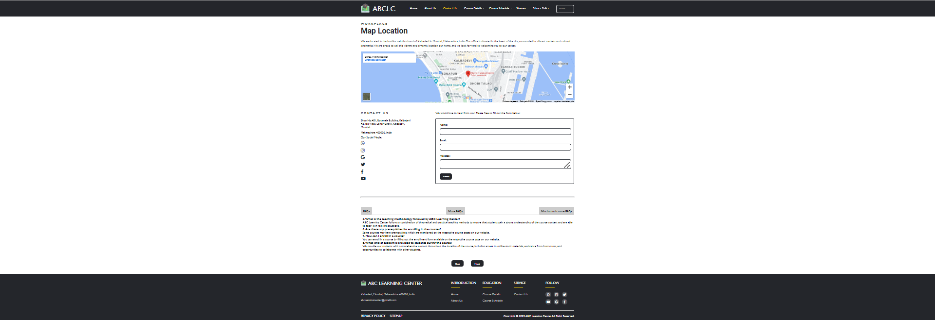

About Us Page includes the header, main content, and footer sections. The main content has three sections: the workplace, contact us sections, and FAQs sections. The workplace section includes a location map and information about the center's location. The contact us section includes the center's address, social media links, and a contact form. The FAQs section includes any frequently asked questions in tabs layout. The website has a responsive design with a hamburger menu that opens and closes the navigation bar. It also has CSS styling, including font-awesome icons and a Google Maps API.

### Course Details Page

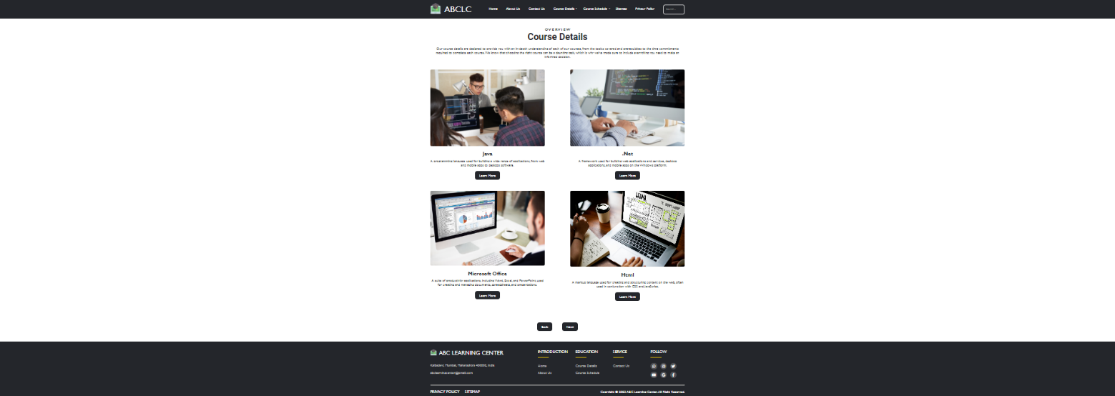

Course Details Page includes a header with a logo, a navigation menu with links to various pages, and a search bar. It also has a section that contains an overview and details of four courses. Each course has an image, a title, a description, and a link to a page with more information about the course. The document is styled using external CSS files and includes a script for the header navigation.

### Course Details Course’s (Templated): Java, .Net, Microsoft Office, HTML

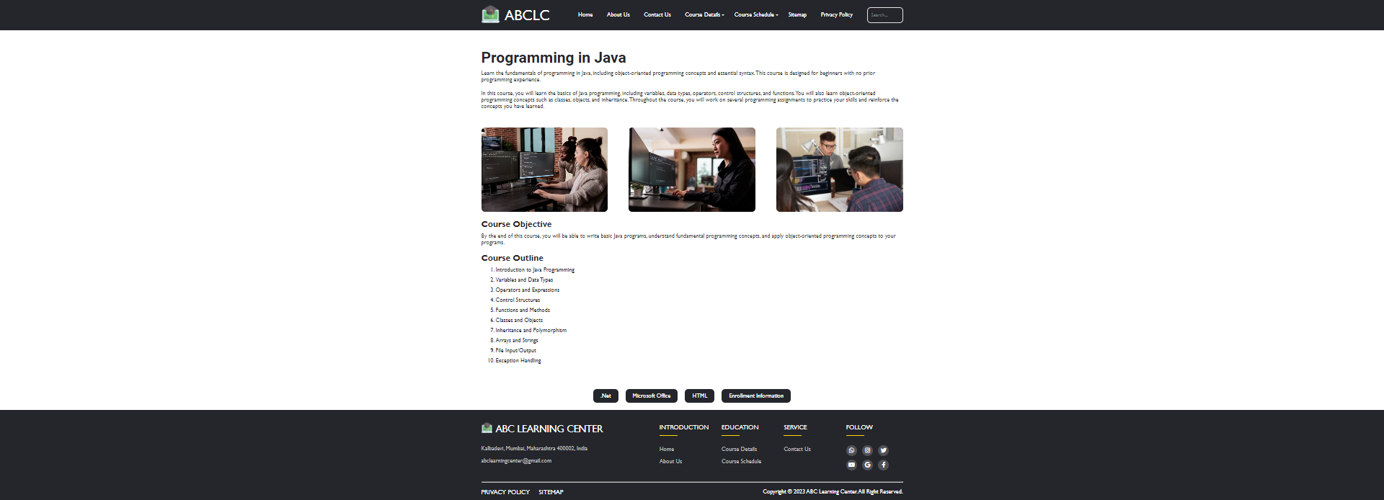

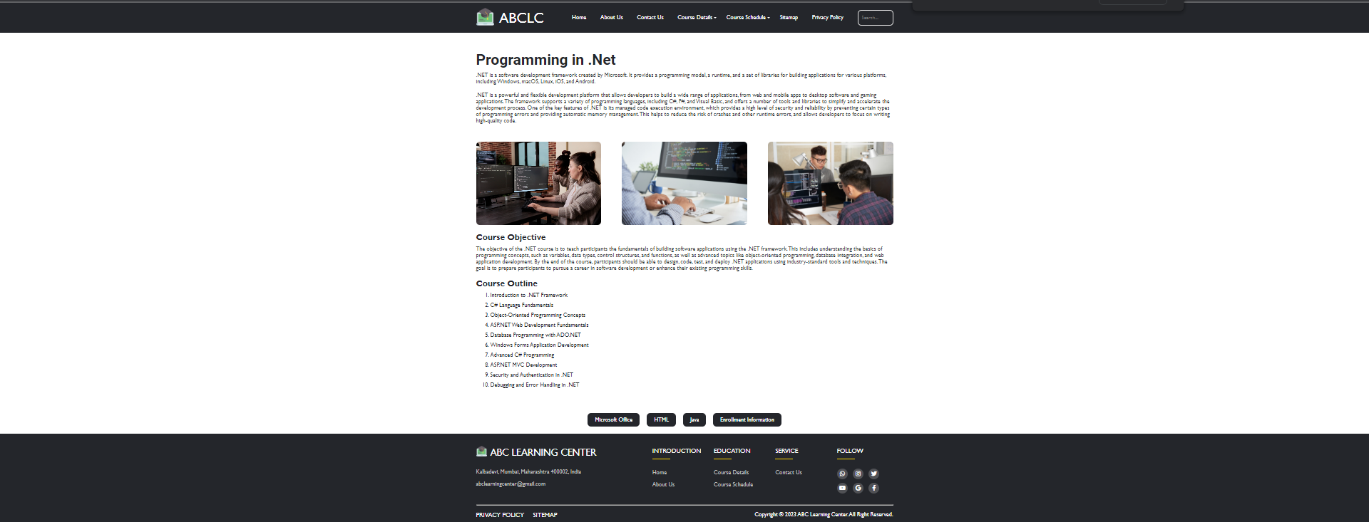

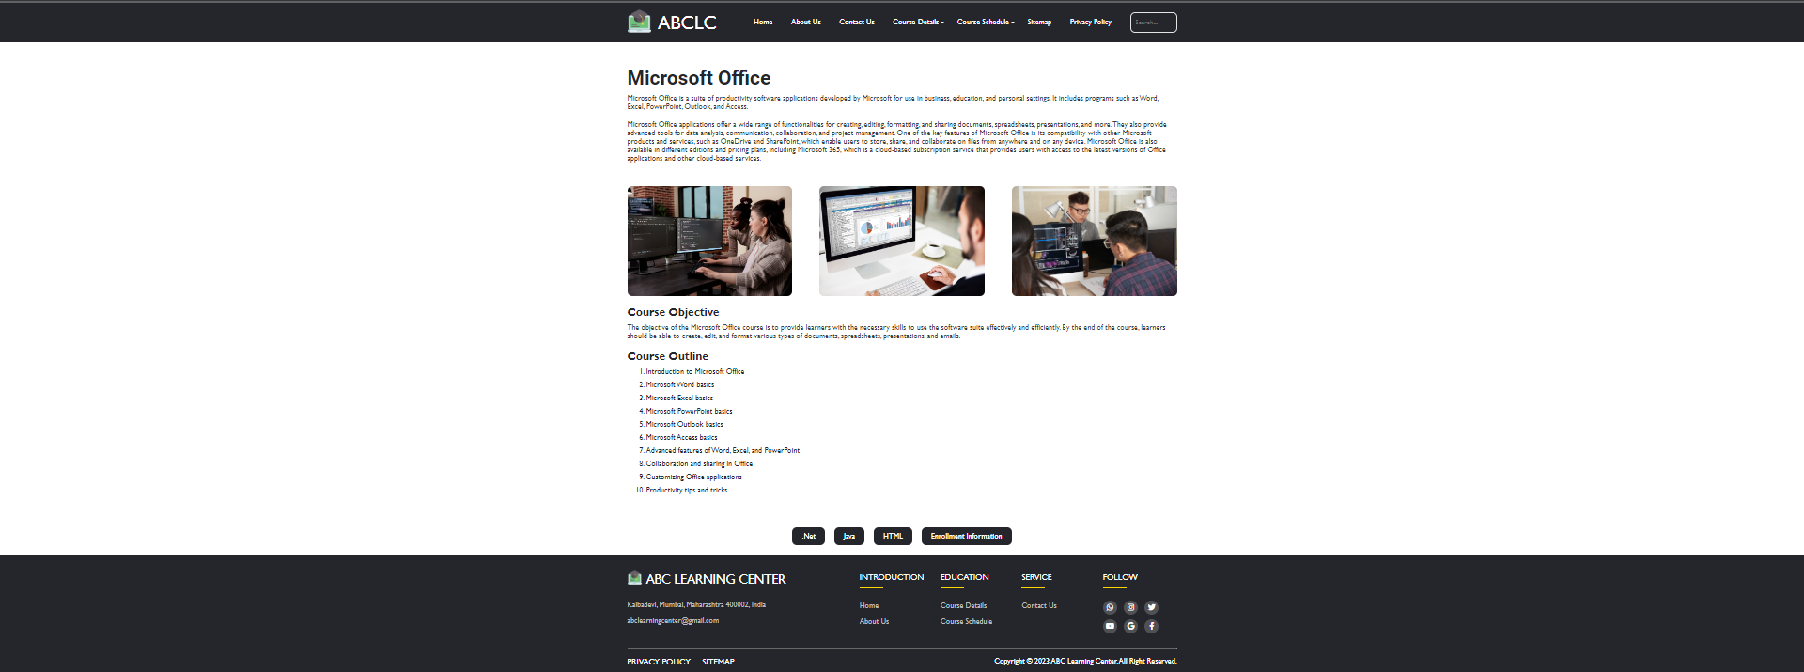

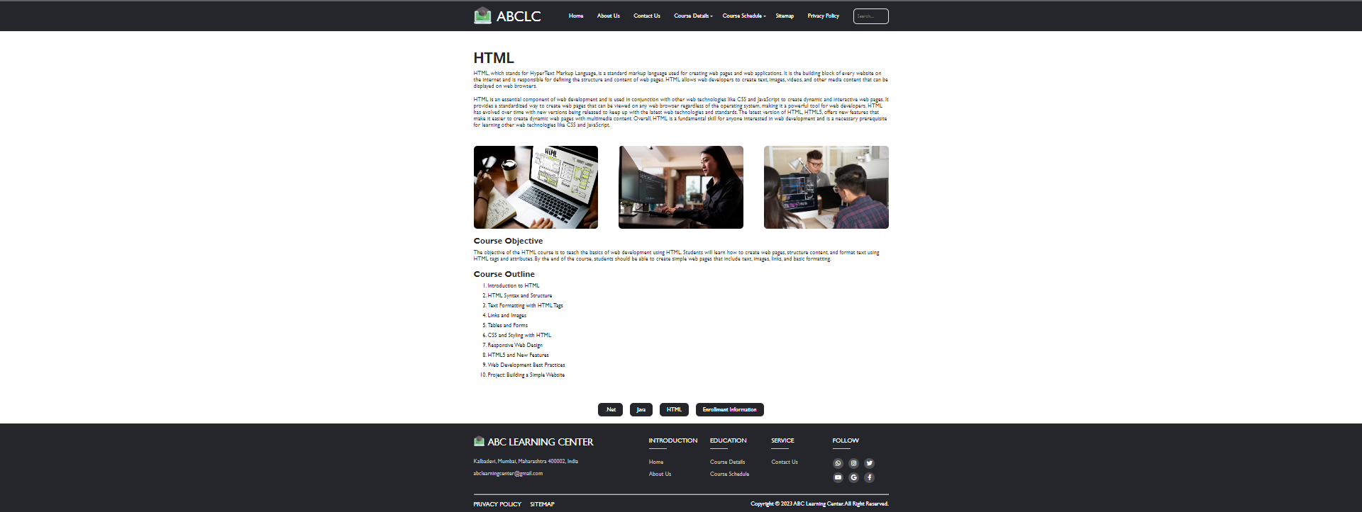

This is a template page for the course details course’s such as Programming in Java, Programming in .Net, Microsoft Office, HTML offered by the "ABC Learning Center." The code includes a header and a main content section. The header has a logo, a navigation bar, and a search bar, and the main content section contains information about the course's description, objectives, and outline. There are also images of people working on a computer and each course’s logo displayed on the page. All the link already displayed and where it supposed to go when it clicked by the user.

### Enrollment Information Page

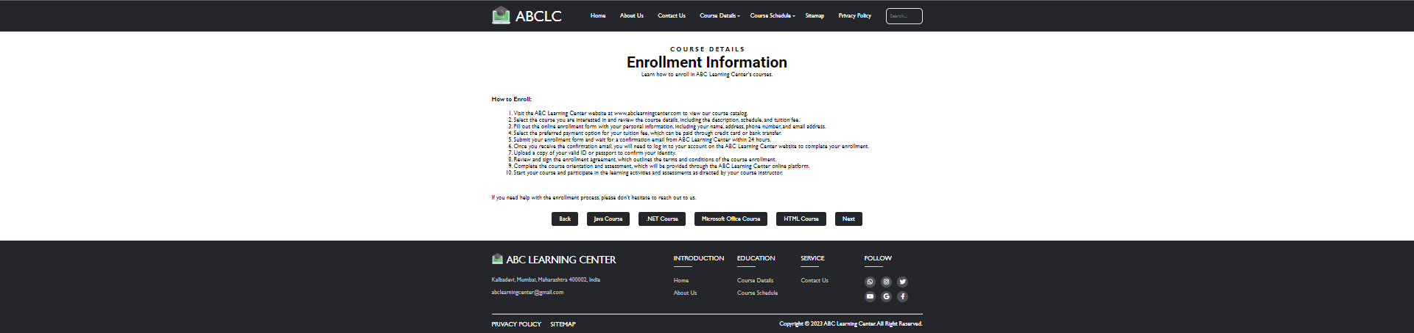

Enrollment Information Page includes a header with a logo, a navigation menu with links to various pages, and a search bar. It also has a section that contains the enroll information for the user if they want to enroll a course. The below button link to various page as it seems on the image, the back button takes user back to Course Details page while next button take the user to Course Schedule page. The document is styled using external CSS files and includes a script for the header navigation.

### Course Schedule Page

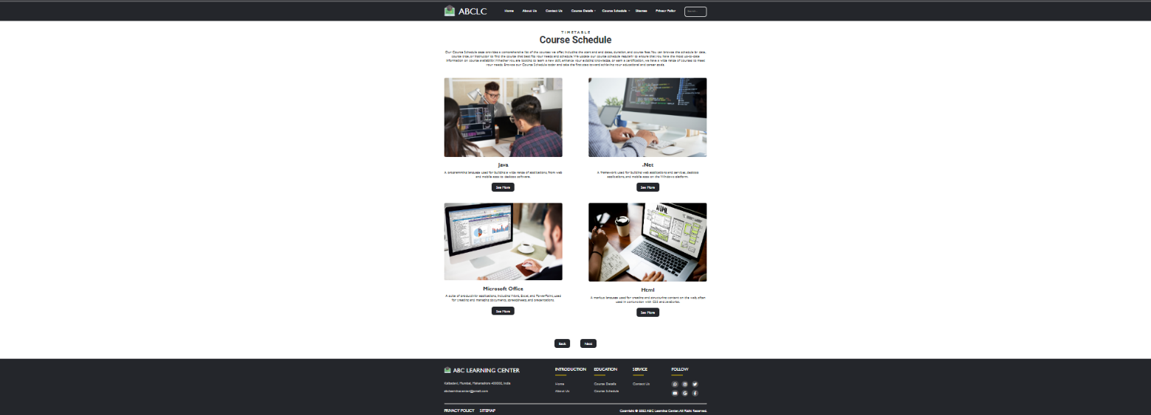

Course Schedule page has common content, the main content showing all course, it has the course image, description, and action button. The action button See more take the user to their chosen course schedule, the back button take the user back to Enrollment Information Page, and the next button take the user to Sitemap page.

### Course Schedule Course’s (Templated): Java, .Net, Microsoft Office, HTML

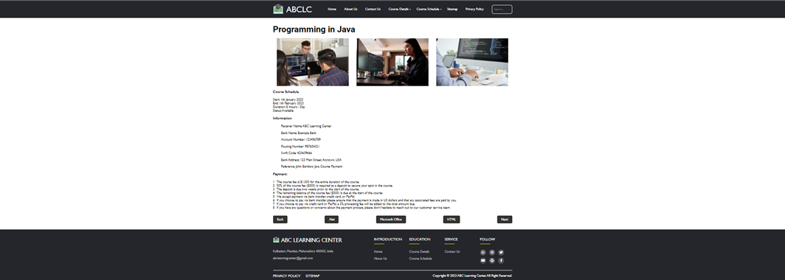

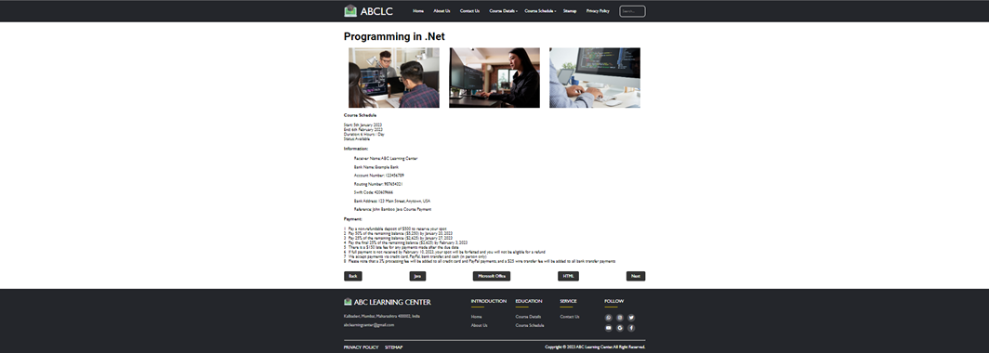

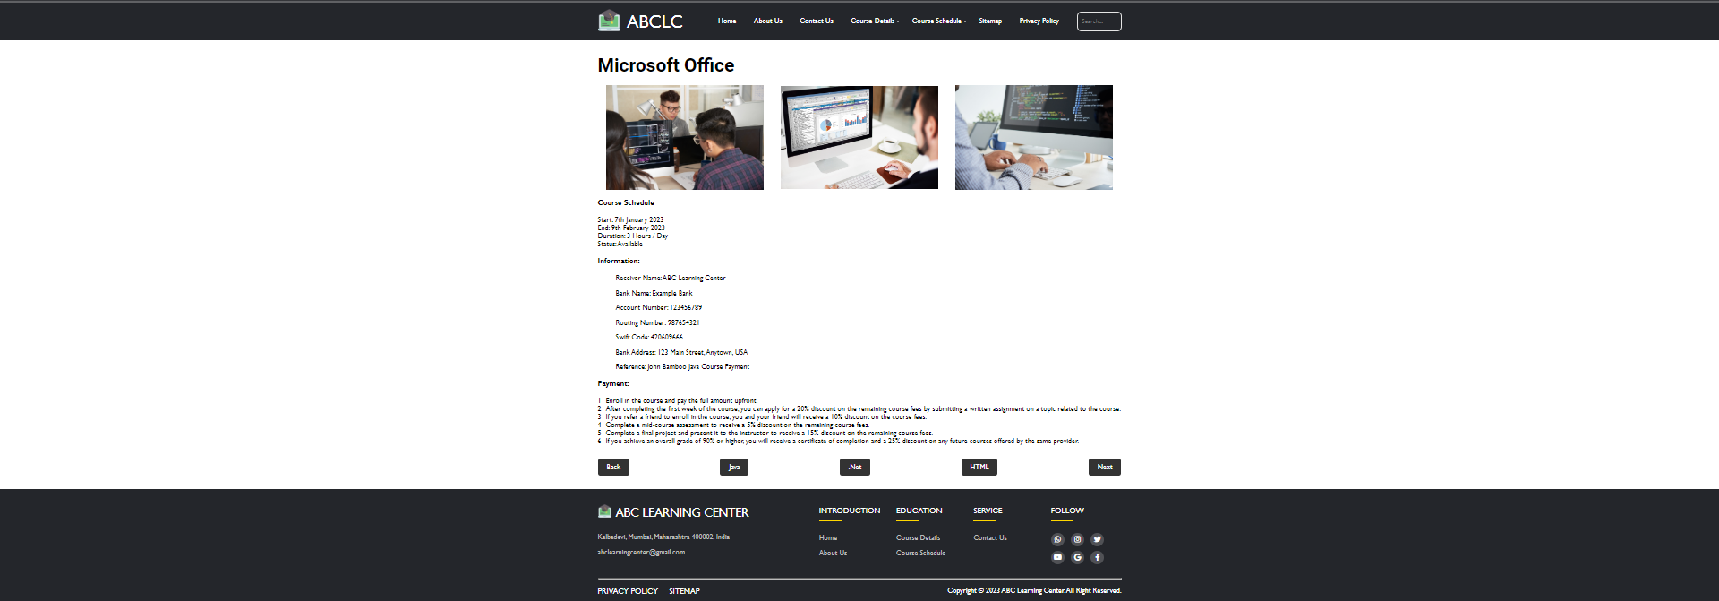



This is a template page for the course schedule course’s such as Programming in Java, Programming in .Net, Microsoft Office, HTML offered by the "ABC Learning Center." The code includes a header, footer and a main content section. The header has a logo, a navigation bar, and a search bar, and the main content section contains information about the course's images, ABC Learning account that tell the information about the company account so the user can send their payment there, and Payment where it shows all regarding information about payment for each course. All the link already displayed and where it supposed to go when it clicked by the user. The back link takes the user back to Course Schedule while the next link takes the user to Sitemap page.

### Sitemap Page

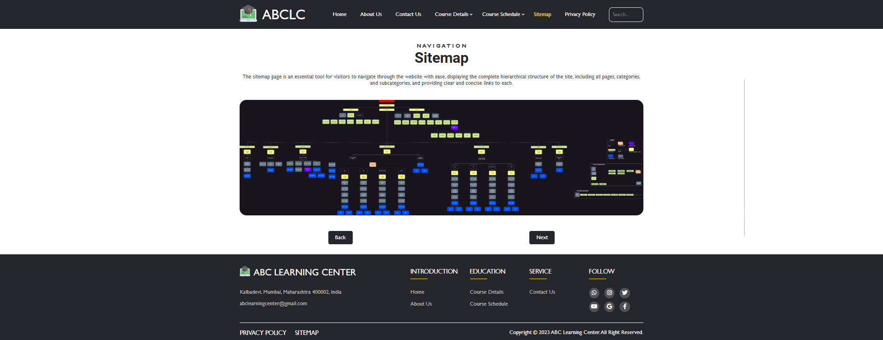

The Sitemap page contain common content, and the main content is just a image of entire sitemap of the webpage, the action button has back button that take user back to Course Schedule page and next button take the user to Privacy Policy page.

### Privacy Policy Page

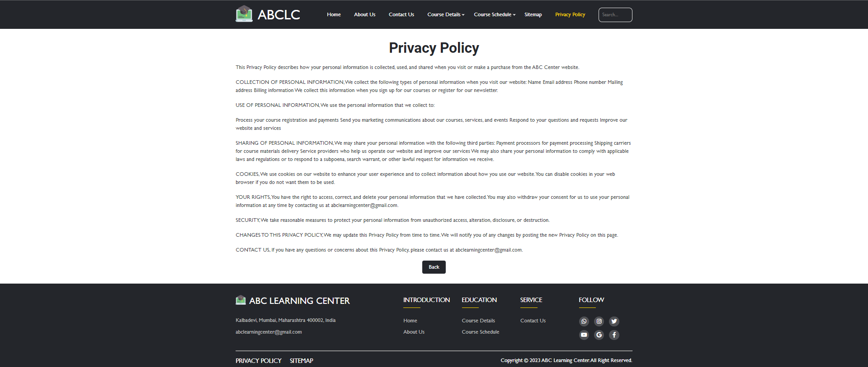

The Privacy Policy Page contain common content, the main content is a full of privacy policy that need to read by the user because it’s important for the user’s sake, the action button is the next button that take the user back to Sitemap page.

# Chapter 5

## Testing and Validation

### Why It Is Needed to Testing and Validating

In software development, testing is the process of verifying that a system, application or feature works as intended and meets the specified requirements. It involves executing tests, analyzing the results and identifying defects, bugs or other issues that need to be addressed.

Validation is the process of evaluating a software product or system to determine whether it meets the user's needs and requirements. It ensures that the software is fit for purpose, is usable and meets the specified quality standards.

Testing and validation are necessary to ensure that the software is reliable, functional and meets the user's needs. Testing helps to identify defects and ensure that the software meets the specified requirements, while validation ensures that the software is fit for purpose and meets the user's expectations. By testing and validating software, organizations can reduce the risk of defects, improve the quality of the software and increase customer satisfaction.

### Types Of Testing and Validation Techniques Used

### Usability Testing

Ideally, Usability tests are executed in the first stage of the design phase during the SDLC. When done early, the Dev team can initiate troubleshooting for any problems sooner, ultimately reducing the cost of fixing the bugs. The longer a digital business waits to perform effective usability tests on the web app, the more the problem becomes a part of the app design, and the more difficult it becomes to remove that issue over time.

One of the primary benefits of usability testing is that it increases the product’s efficiency before launch. By collecting reliable user opinions and identifying their challenges, the project team gets more creative with new solutions and relevant improvements to the current system. Usability testing ensures that the app navigation is user-friendly and the web application’s content is easily accessible.

|  |  |  |  |
| --- | --- | --- | --- |
| Test Scenario ID | Usability-1 | Test Case ID | Usability-1B |
| Test Case Description | Usability – test case | Test Priority | High |
| Pre-Requisite | NA | Post-Requisite | NA |

Test Execution Steps:

|  |  |  |  |  |  |  |  |
| --- | --- | --- | --- | --- | --- | --- | --- |
| S.No | Action | Inputs | Expected Output | Actual Output | Test Browser | Test Result | Test Comments |
| 1 | Checking all Page Content | All Page Current Content | Web page content should be correct without any spelling or grammatical errors | Web page content correct without any spelling or grammatical errors | Chrome | Pass | All the grammar displayed properly |
| 2. | Checking all page fonts | All Page Current fonts | All fonts should be same as per the requirements. | All fonts same as per the requirements. | Chrome | Pass | The Project doesn’t require certain fonts |
| 3 | Checking all page align texts | All Page Current Text | All the text should be properly aligned. | All the text properly aligned. | Chrome | Pass | All text aligned properly |
| 4 | Checking all page current buttons | All Page Current Buttons | All the buttons should be in a standard format and size. | All the buttons in a standard format and size. | Chrome | Pass | All the buttons in a standard format and size. |
| 5 | Checking all the home link in each page | All Current Link Page | Home link should be there on every single page. | Home link are there on every single page. | Chrome | Pass | Home link are there on every single page. |
| 6 | Checking all page image and links | All current page image and links | Check for broken links and images. | No broken links and images. | Chrome | Pass | No broken links and images. |
| 7 | Inspect web | Current Page Resolution | Check the site on different resolutions (640 x 480, 600×800 etc.) | Works fine on different resolutions (640 x 480, 600×800 etc.) | Chrome | Pass | Works fine on different resolutions (640 x 480, 600×800 etc.) |
| 8 | Web Inspect on end device | All current Webpage | Check the end user can run the system without frustration. | End user can run the system without frustration. | Chrome | Pass | End user can run the system without frustration. |
| 9 | Scrolling on long and short page | All current webpage | Scroll bar should appear only if required. | Scroll bar appear only if required. | Chrome | Pass | Scroll bar appear only if required. |
| 10 | Checking all title on every page | All current webpage | Title should display on each web page. | Title already displayed on each web page. | Chrome | Pass | Title already displayed on each web page. |

### Functional Testing

Users should be able to follow the simplest route possible to perform any action. They do not desire a website or web app full of bugs and incorrect features. Application flaws are easily identified through functional testing. If the application’s coding or qualities improve, the Dev team can adhere to the test results and make the necessary changes. Thus, it ultimately results in the web application’s functioning improvement.

Additionally, this test would provide insight into the application’s ability to perform as expected. QA engineers verify that the initial build works as per the predefined requirements. Common features tested in functional testing are links, cookies, HTML & CSS, etc.

|  |  |  |  |
| --- | --- | --- | --- |
| Test Scenario ID | Functional-1 | Test Case ID | Functional -1B |
| Test Case Description | Functional – test case | Test Priority | High |
| Pre-Requisite | NA | Post-Requisite | NA |

Test Execution Steps:

|  |  |  |  |  |  |  |  |
| --- | --- | --- | --- | --- | --- | --- | --- |
| S. No | Action | Inputs | Expected Output | Actual Output | Test Browser | Test Result | Test Comments |
| 1 | Checking max length of all Page Content | All Page Current max length | Test the max length of every field to ensure the data is not truncated. | Max length of every field is fine. | Chrome | Pass | Max length of every field is fine. |
| 2. | Checking all input | All Page Current input | Test all input fields for special characters. | All input fields for special characters works well. | Chrome | Pass | All input fields for special characters works well. |
| 3 | Checking all page buttons | All Page Current buttons | Test the functionality of the buttons available | Functionality of the buttons works well | Chrome | Pass | Functionality of the buttons works well |
| 4 | Checking all page privacy and FAQs | All Page Current privacy and FAQs | Test the Privacy Policy & FAQ is clearly defined and should be available for users. | Privacy Policy & FAQ is clearly defined and available for users. | Chrome | Pass | Privacy Policy & FAQ is clearly defined and available for users. |
| 5 | Checking all the webpage | All Current Page | Test all the uploaded documents are opened properly. | All the uploaded documents are opened properly. | Chrome | Pass | All the uploaded documents are opened properly. |
| 6 | Checking all page | All current page | Test the user should be able to download the uploaded files. | The user able to download the uploaded files. | Chrome | Pass | The user able to download the uploaded files. |
| 7 | Checking all email link page | Current Page email link | Test the email functionality of the system. | Email functionality of the system works well. | Chrome | Pass | Email functionality of the system works well. |
| 8 | Testing the Java Script on another browser | Header JS test | Test the Java script is properly working in different browsers (IE, Firefox, Chrome, safari and Opera). | The Java script is properly working in different browsers (IE, Firefox, Chrome, safari and Opera). | Chrome, IE, Firefox, safari and Opera | Pass | The Java script is properly working in different browsers (IE, Firefox, Chrome, safari and Opera). |
| 9 | Checking data in every webpage | All current webpage data | Test all the data inside combo/list box is arranged in chronological order. | All the data inside combo/list box is arranged in chronological order. | Chrome | Pass | All the data inside combo/list box is arranged in chronological order. |
| 10 | Checking all asterisk sign | All current webpage | Test the asterisk sign should display for all the mandatory fields. | The asterisk sign displayed for all the mandatory fields. | Chrome | Pass | The asterisk sign displayed for all the mandatory fields. |

### Compability Testing

The compatibility of a system, application, or website is built with various factors and objects, such as databases, web browsers, hardware platforms, operating systems, users, mobile devices, networks, etc. Compatibility testing, as the name goes, measures the web app’s compatibility across a wide range of environments.

Compatibility testing ensures that the web app meets all the predefined business requirements of both the developer and the end user. This stable web app improves the credibility of the associated organization. There is no denying that quality web apps improve a business’s sales and marketing efforts and optimize customer engagement.

|  |  |  |  |  |  |  |  |
| --- | --- | --- | --- | --- | --- | --- | --- |
| S.No | Action | Inputs | Expected Output | Actual Output | Test Browser | Test Result | Test Comments |
| 1 | Testing the website in different browsers | Entire current webpage | Test the website in different browsers (IE, Firefox, Chrome, Safari and Opera) and ensure the website is displaying properly. | The website displayed properly in different browsers | IE, Firefox, Chrome, Safari and Opera | Pass | The website displayed properly in different browsers |
| 2 | Testing the website with appropriate browser versions. | Entire current website | Test the HTML version being used is compatible with appropriate browser versions. | The HTML compatible with appropriate browser versions | Chrome | Pass | The HTML compatible with appropriate browser versions |
| 3 | Testing website image on different browser | Entire current image | Test the images display correctly in different browsers. | Images displayed correctly in different browsers | IE, Firefox, Chrome, Safari and Opera | Pass | Images displayed correctly in different browsers |
| 4 | Testing website fonts on different browser | Entire website fonts | Test the fonts are usable in different browsers. | Fonts are usable in different browsers | IE, Firefox, Chrome, Safari and Opera | Pass | Fonts are usable in different browsers |
| 5 | Testing the java script code in different browsers. | Header.js test | Test the java script code is usable in different browsers. | The java script code is usable in different browsers | IE, Firefox, Chrome, Safari and Opera | Pass | The java script code is usable in different browsers |
| 6 | Testing buttons and links across devices and platforms | Entire website buttons and links across devices and platforms | Test buttons and links across devices and platforms. | Buttons and links across devices and platforms work properly | IE, Firefox, Chrome, Safari and Opera | Pass | Buttons and links across devices and platforms work properly |
| 7 | Testing text alignment, dropdown, and issues with alignment of other elements. | Entire website text alignment, dropdown, and issues with alignment of other elements | Test for text alignment, dropdown, and issues with alignment of other elements. | Text alignment, dropdown, and issues with alignment of other elements properly fine | Chrome | Pass | Text alignment, dropdown, and issues with alignment of other elements properly fine |
| 8 | Testing web app’s scalability to fit according to size, tables, and borders | Entire webpage | Test for web app’s scalability to fit according to size, tables, and borders. | Web app’s scalability to fit according to size, tables, and borders works fine | Chrome | Pass | Web app’s scalability to fit according to size, tables, and borders works fine |
| 9 | Verifying fields and their inputs. | Entire webpage | Verify fields and their inputs. | Verified fields and their inputs | Chrome | Pass | Verified fields and their inputs |
| 10 | Checking app background color across all screens | All current webpage app background color | Check app background color across all screens. | App background color across all screens works fine | Chrome | Pass | App background color across all screens works fine |

### Performance Testing

The performance testing process helps evaluate the stability and responsiveness of websites and web applications. Performance testing is executed to ensure the web app loads fast enough, does not crash under varying loads, and the overall performance enhances the user experience.

Performance testing validates the web app against different load and stress conditions and at different internet connection speeds to ensure proper scalability of the web app.

|  |  |  |  |  |  |  |  |
| --- | --- | --- | --- | --- | --- | --- | --- |
| S.No | Action | Input | Expected Output | Actual Output | Test Browser | Test Result | Test Comments |
| 1 | Load the ABC Learning Center homepage | Website index.html | The homepage should load without errors and within a reasonable amount of time | The homepage loaded in 3 seconds without any errors | Chrome | Pass | The homepage loaded quickly and without any issues |
| 2 | Test app performance over multiple devices and OS | Access the ABC Learning Center app on different devices and OS | The app should function correctly on all tested devices and operating systems | The app functioned correctly on an iPhone with iOS 14 and a Windows PC running Chrome | iPhone with iOS 14, Windows PC running Chrome | Pass | The app functioned correctly on all tested devices and operating systems |
| 3 | Test battery consumption | Use the ABC Learning Center app on a mobile device for a set period of time | The app should not cause excessive battery drain | The app consumed 5% of battery over 1 hour of use | iPhone with iOS 14 | Pass | Battery consumption was reasonable for the amount of time the app was used |
| 4 | Test network scalability | Simulate varying network conditions while using the app | The app should function correctly and without errors under different network conditions | The app functioned correctly under both Wi-Fi and cellular network conditions with varying strengths | iPhone with iOS 14 | Pass | The app functioned correctly under different network conditions |
| 5 | Test memory and CPU utilization | Use the app on a device with limited resources | The app should not cause the device to crash or become unusable | The app used 120 MB of memory and 15% of CPU while in use | Windows PC running Chrome | Pass | Memory and CPU utilization were within reasonable limits and did not cause any issues |
| 6 | Test app performance under varying load | Simulate different levels of user activity while using the app | The app should function correctly and without errors under varying load conditions | The app functioned correctly under both low and high load conditions | Windows PC running Chrome | Pass | The app functioned correctly under varying load conditions |
| 7 | Test app behavior during network fluctuations | Simulate network fluctuations while using the app | The app should continue to function correctly and without errors during network fluctuations | The app functioned correctly during multiple network disruptions | iPhone with iOS 14 | Pass | The app functioned correctly during network fluctuations |
| 8 | Test app performance on low-end device | Test app performance on low-end device | The app should perform with acceptable response times and without crashing or freezing | N/A | Google Chrome | Not Tested | This test will help to determine if the app can be used on low-end devices without significant performance issues. |
| 9 | Test app behavior during interruptions | Simulated network interruptions and errors | The app should handle interruptions gracefully and display error messages or alerts when necessary | N/A | Mozilla Firefox | Not Tested | This test will help to ensure that the app is resilient to network errors and that users are informed of any issues that may occur. |
| 10 | Test app accessibility | Assistive technology software (e.g. screen readers) | The app should be accessible to users with disabilities, with appropriate text alternatives and keyboard navigation support | N/A | Safari | Not Tested | This test will help to ensure that the app meets accessibility standards and can be used by all users, regardless of their abilities. |

### Responsive Testing

Responsive web design targets for websites to react to their device, resolution and be able to render and adapt correctly. For example, if the user switches from desktop/ laptop to iPad, then the website should automatically adapt the resolution changes like image size etc. as per the respective device abilities.

In Responsive Web Design, a website is designed to give a superior user experience through easy navigation, clear and simple user interface, etc. Responsive websites adapt easily and work in all resolutions, browsers, screen sizes, hardware, and Operating Systems.

|  |  |  |  |  |  |  |  |
| --- | --- | --- | --- | --- | --- | --- | --- |
| S.No | Action | Input | Expected Output | Actual Output | Test Browser | Test Result | Test Comments |
| 1 | Verify images display | Website on different devices and resolutions | All images displayed properly | Pass | Google Chrome on Windows 10 | Pass | Images displayed properly on different devices and resolutions. |
| 2 | Verify text alignment | Website on different devices and resolutions | All text and headings properly aligned | Pass | Mozilla Firefox on macOS Big Sur | Pass | Text and headings properly aligned on different devices and resolutions. |
| 3 | Verify clickable links | Website on different devices and resolutions | All clickable links are readable and working | Pass | Safari on iOS 15 | Pass | All clickable links readable and working as expected. |
| 4 | Verify scrolling functionality | Website on different devices and resolutions | Scrolling works as expected | Pass | Google Chrome on Android 11 | Pass | Scrolling works smoothly and without any issues. |
| 5 | Verify input boxes and text areas | Website on different devices and resolutions | Text entered is displayed properly and aligned | Pass | Microsoft Edge on Windows 11 | Pass | Text entered is displayed properly and aligned as expected. |
| 6 | Verify consistency in design | Website on different pages | Image size, Font size, and Font type consistent | Pass | Google Chrome on Windows 11 | Pass | Design consistent across all web pages. |
| 7 | Verify consistent display | Website on different resolutions | Contents of the page displayed consistently | Pass | Safari on macOS Monterey | Pass | Contents displayed consistently on different resolutions. |
| 8 | Verify color changes on hover | Website on different devices and resolutions | Color changes after hover over the elements | Pass | Mozilla Firefox on Windows 10 | Pass | Color changes on hover as expected. |
| 9 | Verify consistency in color | Website on different resolutions | Color combination consistent | Pass | Google Chrome on macOS Big Sur | Pass | Color combination consistent across different resolutions. |
| 10 | Verify no screen border overlap | Website on different devices and resolutions | Images, text, controls do not go beyond screen border | Pass | Safari on iPadOS 15 | Pass | No screen border overlap found. |

### Software Specify

* Selenium: A popular automated testing tool that can be used to test web applications. It supports a variety of programming languages and can simulate user interactions with web pages.
* Appium: An open-source mobile automation framework that can be used to test native, hybrid, and mobile web applications. It supports multiple programming languages and can run on both iOS and Android devices.
* Browser Stack: A cloud-based testing platform that allows testers to test web applications on multiple browsers and operating systems without having to set up a testing environment. It supports manual and automated testing.
* JMeter: A Java-based open-source load testing tool that can be used to test the performance and scalability of web applications. It can simulate heavy load on a server and measure its response time and stability.
* Postman: An API testing tool that can be used to test the API endpoints of web applications. It supports REST and SOAP APIs and allows testers to send requests and receive responses from APIs.
* TestRail: A test management tool that can be used to plan, manage, and track software testing. It allows testers to create test cases, track test results, and generate reports on testing progress and coverage.

### Citation

(https://www.guru99.com/complete-web-application-testing-checklist.html, n.d.) (https://testsigma.com/blog/web-app-testing-checklist/#Sample_use_cases_to_be_considered, n.d.)

(https://www.softwaretestinghelp.com/responsive-web-design-testing-guide/, n.d.)